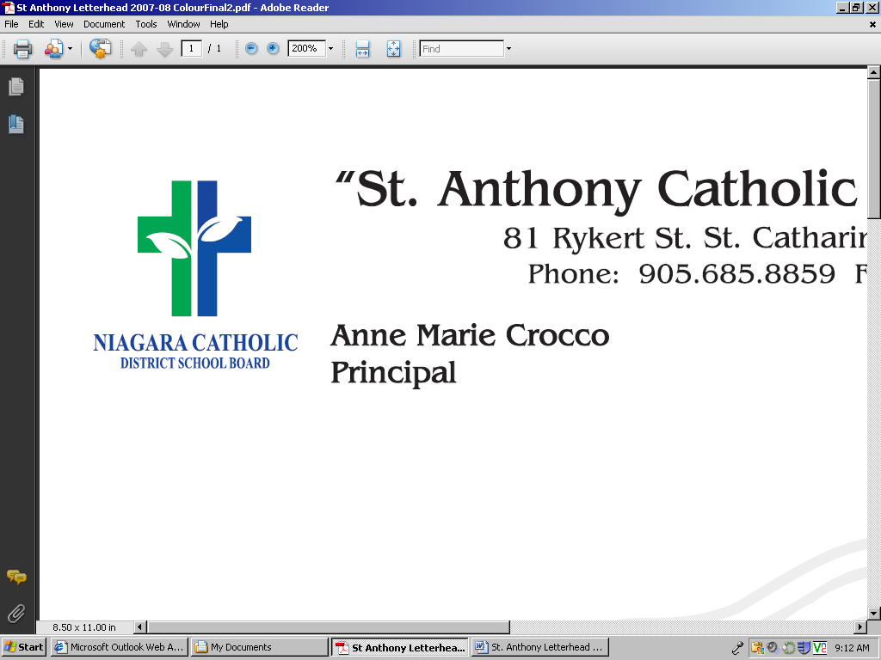
Appendix A

This information is collected under the authority of the Education Act and in compliance with the Municipal Freedom of Information and Protection of Privacy Act (MFIPPA) and will be used for the purposes of evaluating prospective volunteers for Niagara Catholic. Questions about this collection should be directed to the relevant Superintendent of Education, Niagara Catholic District School Board, 427 Rice Road, Welland, ON, L3C 7C1, 905-735-0240.

VOLUNTEER APPLICATION FORM

First Name: | Last Name:
Contact #: | Email:

I, wish to volunteer at
(Name of School)

As a volunteer I acknowledge and will adhere to the following expectations:

- I have read, and agree with the Niagara Catholic Volunteers AOP (800.9).
- I agree to model and uphold the Mission, Vision, Values and the Governance Policies and Administrative Operational Procedures of the Board, adhere to the Catholic education expectations, and support the creation of a safe and welcoming learning and working environment.
- I understand that I am required to submit a satisfactory Police Vulnerable Sector Check (dated within six months), on a five-year renewal cycle, at my own expense, and sign a Volunteer Offence Declaration prior to September 1, in subsequent years. A Volunteer Offence Declaration will stand as a legally binding document.
- I understand that I am to immediately report Criminal Code charges or convictions to the principal and obtain a new required Police Vulnerable Sector Check if charged with an offence.
- I understand that I must complete a one time training on accessibility, and provide proof of the Integrated Accessibility Standards Regulation Certificate of Training and the Ontario Human Rights Commission Certificate of Completion, in accordance with the Ontario Human Rights Commission: Working Together Accessibility for Ontarians with Disabilities Act, prior to volunteering.
- I understand that I must complete updated AODA training modules, as required, and provide proof of completion to the principal.
- I understand my role and responsibilities as a volunteer driver, if applicable.
- I shall assist under the supervision and direction of school principal, and staff.
- I shall seek assistance from staff and/or the school principal, when faced with any challenges while acting as a volunteer.
- I understand that classroom teachers and school administrators are solely responsible for student discipline.
- I understand that this agreement pertains to all school and off-site activities/events such as educational field trips as they are an extension of the school.
- I acknowledge that in the course of my volunteer work that confidential information with respect to staff, students, parents/guardians, the school and/or the Board may be disclosed.
- I hereby agree not to disclose, at any time, such confidential information to any individual.
- I acknowledge that as a volunteer, I will not receive remuneration.

Volunteer’s Signature: | Date:
Principal’s Signature: | Date:

