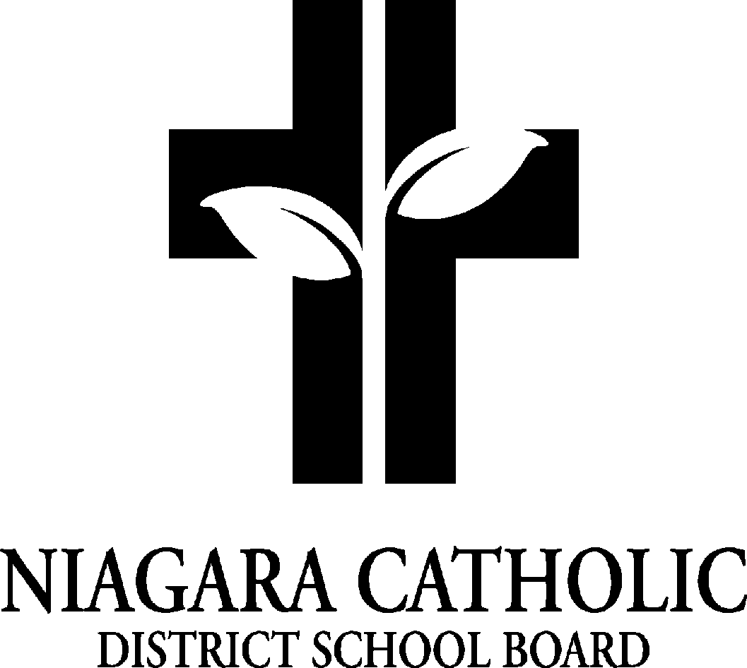

St. Alexander Catholic School Council
AGENDA
Tuesday, January 27, 2026 - 5:30 pm

- Prayer -
- 2. Role Call
3. Chair Report
i) Shrove Tuesday - Feb 17th, 2026
ii) Fundraising - Purse Bingo - dates and process
4. Principal’s Report

i.Policy vetting
ii. Kindergarten Registration Open House - Feb 5th, 9a-6p
iii. Report Cards & Interviews by request - Reports to parents via Portal week of Feb. 9th
iv . Notre Dame Open House for Grade 8’s - was 6:30 pm on Jan. 14th - feedback?
v.Other happenings: Kids Helping Kids week - (activity schedule to follow soon), Valentine’s Dance-a-thon - Feb 12th, PA Day - Feb. 13th, Shrove Tuesday, Feb. 17th, Ash Wednesday Mass - Feb. 18th
vi . Fundraising and Tech purchases
vii . Gym Construction Update

5. School Improvement / Staff Report
EQAO scores for St. Alexander - what they mean
· compared to NCDSB and Ontario
DOT scores and what we are doing as a learning team
- Looking at those students that are close to levels 2.8, 2.9, and 3.1,3.3… How many level 4’s? etc…

6. Treasurer’s Report

St. Alexander Catholic School
Tuesday, January 27, 2026
Financial Statement

General Fundraising

Fundraising Activities Expense Revenue Balance

General Fundraising |  |  | $1,935.53
Food Days | $22,339.45 | $33,966.20 | $11,626.75

Overall Totals |  |  | $13,562.28

Next Meeting Date: March 24, 2026 @5:30 PM

Closing Prayer:
Our Father, Who art in heaven,
Hallowed be Thy Name.
Thy Kingdom come.
Thy Will be done,
on earth as it is in Heaven.

Give us this day our daily bread.
And forgive us our trespasses,
as we forgive those who trespass against us.
And lead us not into temptation,
but deliver us from evil.
Amen.

