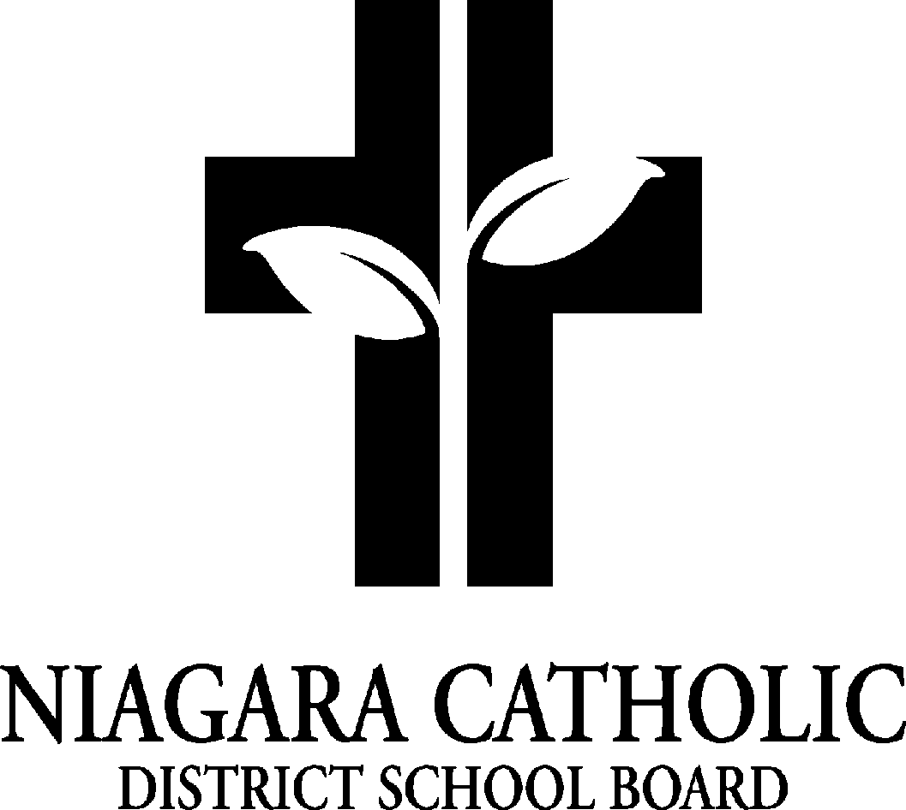

St. Alexander Catholic School Council
AGENDA
Tuesday, November 25, 2025 - 5:30 pm

- Prayer:
Roll Call

Principal (Treasurer) | Mr. Venzon
Vice Principal (Secretary) | Mr. Leheta
Teacher Representative | Ms. Principi
Chair (s) | Kristin DeDivitiis | Alycia Tallman | Both Present
Members |  | Email | Grade  Child/Children
Tiffany Miller |  | tiffanyjim0531@gmail.com | Jaxon SK
Jennifer Gasparotto |  | Absent
Andre Policella |  | Absent
Larissa Bader |  | Absent
Jade Jones |  | j_jonesw@hotmail.com | Caia McNair, Gr. 5
Maria Reid |  | maria4health@gmail.com | Liam Reid, Gr. 2  Lucas Reid, Gr. 4
Sarah Musso |  | themussos@gmail.com | Tessa, Gr. 4  Paulo, Gr. 5
Amada Preston |  | amanda.aiello@hotmail.com | Thomas Preston SK
Lisa Chandler
Ashley Baro |  | absent
Ashley Baron |  | ash.reinhardt1@gmail.com | Madison Barron - SK  Adelyn Barron, Gr. 2
Victoria Jaski |  | victoriamjaski@gmail.com | Evie, Gr. 2  Jonny, Gr. 5  Elizabeth Jaski, Gr. 7
Regrets
Chrissa Carrier

- Chair Report
i) Food Days - Pita Pit, Pizza, Subway, Pasta Day
- Dominos - Red Sauce not great
- Big Reds - much better
  - local and easy choice to go with it

ii) Fundraising Update
- Sons and Daughters Winery
  - 20% goes to St. Alexander
    - As of Nov 24: $1,911. 42 total sales $382.28 - back to school
  - Send home flyers with children for the future campaigns
  - Post on Social media (Facebook and Instagram - Eller)
  - Post on Messenger Monday, Dec 1st - Yass
- Christmas at Amici’s
  - Great deal
  - Choir will perform with Ms P
    - Kids will play a few songs - 6-8 PM
    - CSC organize a schedule with Ms. P
      - Ms P to practice with the choir and musicians
    - The Christmas truck is coming to Amici’s (possibly)
    - Possibly a food donation at the restaurant, get the bins
    - Food drive to post on Social media
    - cookies, 50/50 tickets and crafts to generate funds

- Principal’s Report

- Policy vetting
- Kindergarten Christmas Make and Take - December 3rd
- St. Alexander Advent Mass - December 3rd
  - Kinders will do a craft event for parents
    - Make and Take for families
- School-wide Reconciliation - was November 12th
- Grade 2 First Reconciliation - November 19th
- Christmas Food Drive - information sent to all parents
  - Dec 1-17 for Pelham cares
  - The Thanksgiving food drive was good
- Notre Dame Open House for Grade 8’s 6:30 pm on Jan. 14th, 2026
- Grade 8 Graduation - popcorn sales continue
  - Sales are good
- Other happenings: Grades 3-6 to Wizard of OZ- Dec. 5,
- Advent Services x4,
  - over announcements
- Christmas Choir performs at the Seaway Mall- Dec.10
- gym project update
  - walk through to see progress
  - Valentine's Day dance and glow sticks
- School pictures
  - Lifetouch is not very professional
  - Pegasiss's service was great
    - The package was good
    - Every Home Room has a package sent in alphabetical order
    - The background was not as crisp (more options for digital background and grade)
    - 3 weeks for the digital image to be delivered or edited
    - Quick deadline - more expensive, approx $10 more

- St. Alexander social media
- Chromebooks purchased - 20
  - purchased new ounces that have expired

5. School Improvement / Staff Report
EQAO scores for St. Alexander - Not yet received
- Once received, we will compare to the NCDSB and Ontario, and look at DOT scores and what we are doing as a learning team. We will be looking at students who are close to the next level (2.8, 2.9), making them our target students for tier 2 small-group instruction.

6. Treasurer’s Report

St. Alexander Catholic School
Tuesday, November 25, 2025
Financial Statement

General Fundraising

Fundraising Activities Expense Revenue Balance

General Fundraising |  |  | 953.17
Food Days |  |  | 8,234.25

Overall Totals |  |  | 9,187.42

Next Meeting Date: Tuesday, January 27, 2026 - 5:30 pm

Closing Prayer:

