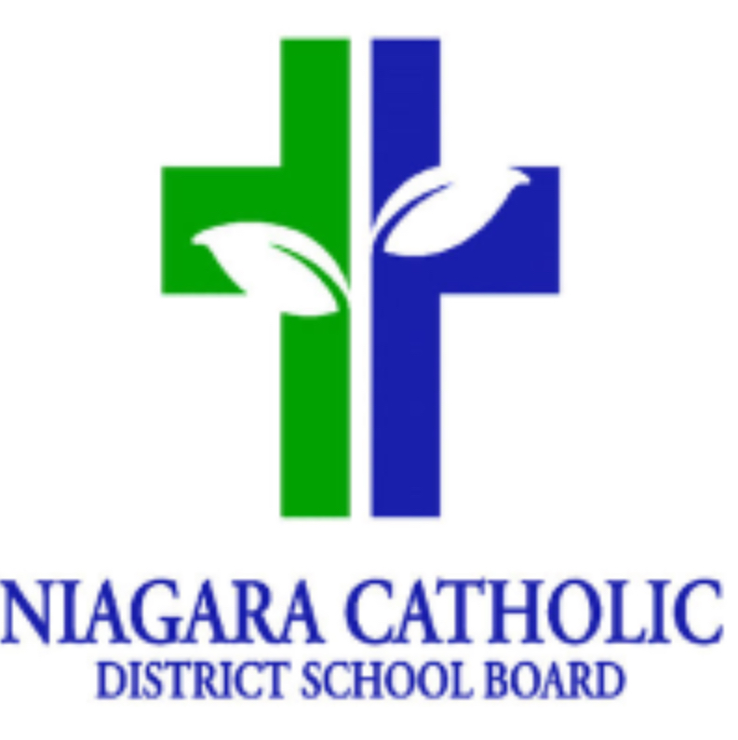
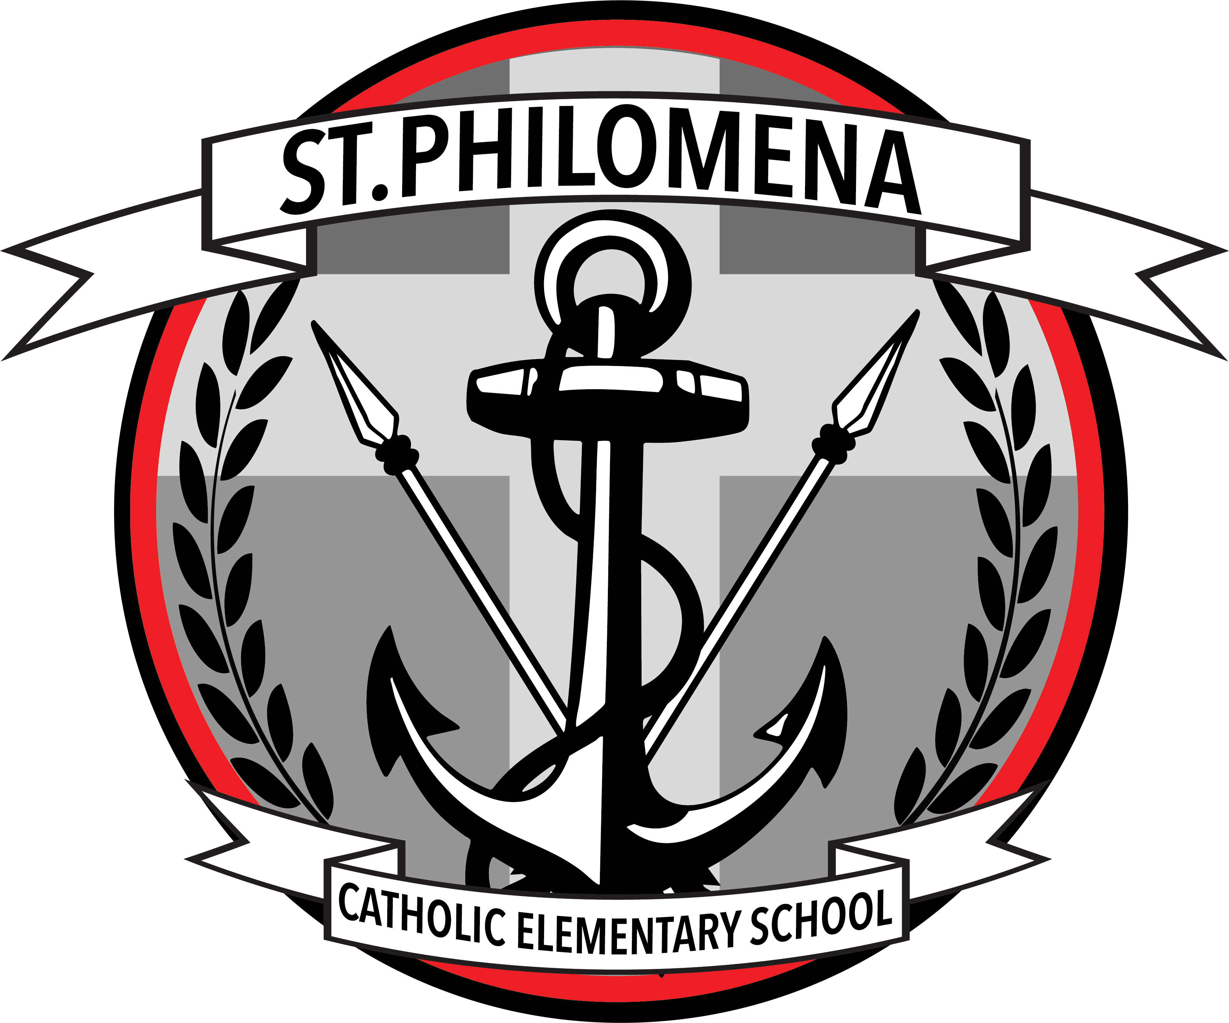
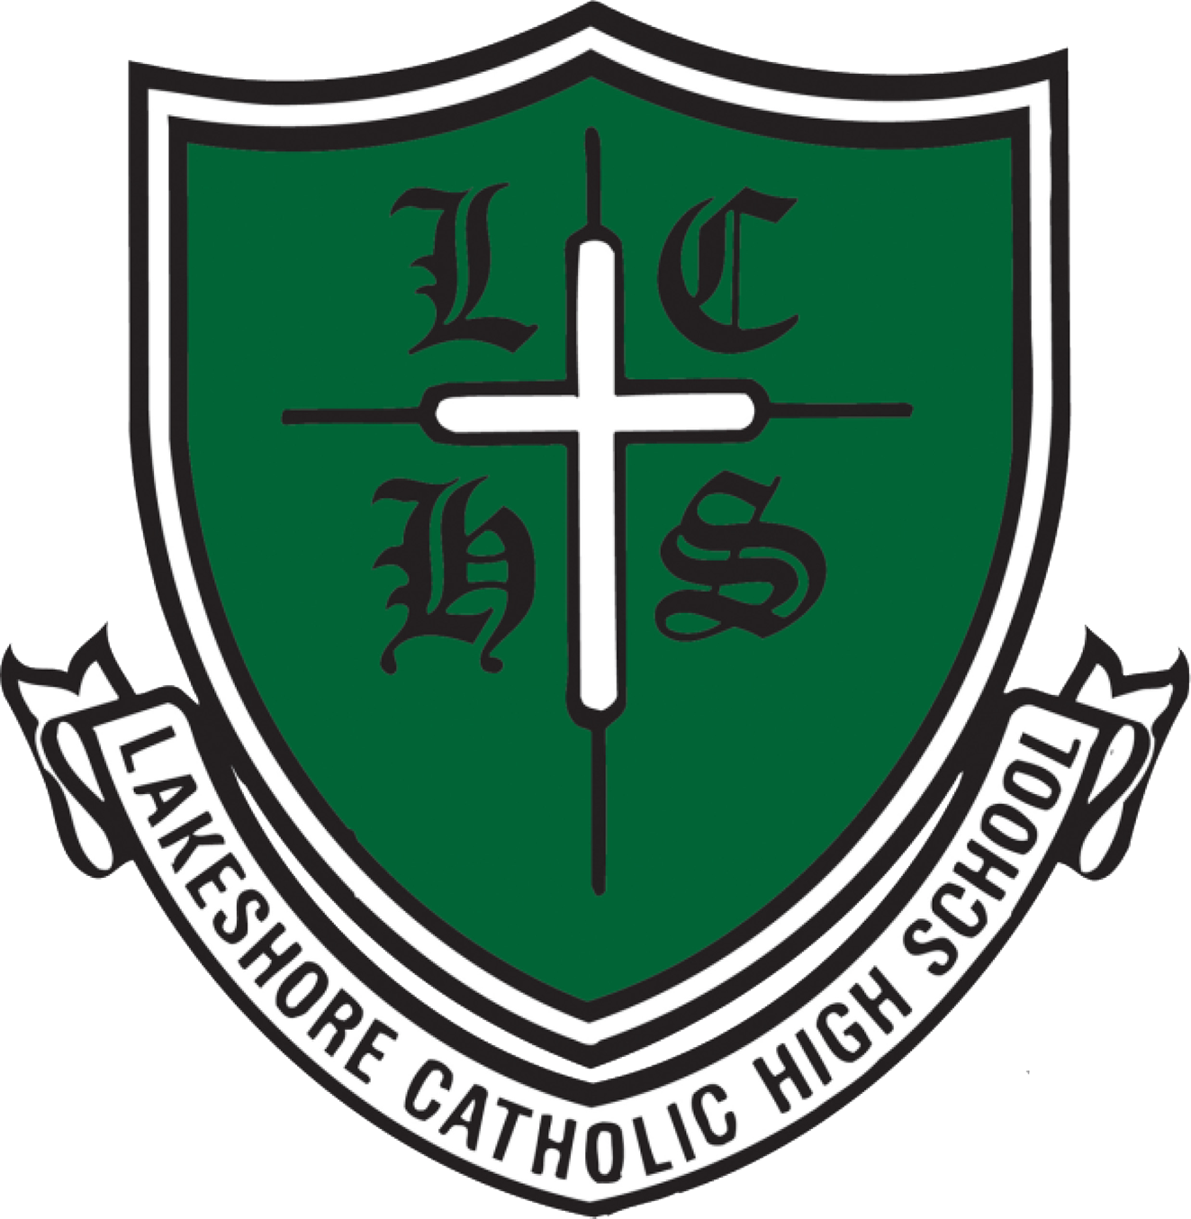
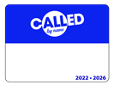
September 2025
Theological Theme – Called by Name “Go and Make Disciples” 2025 2026
St. Philomena School is a member of the Lakeshore Catholic Family of Schools

Sunday | Monday | Tuesday | Wednesday | Thursday | Friday | Saturday
 | 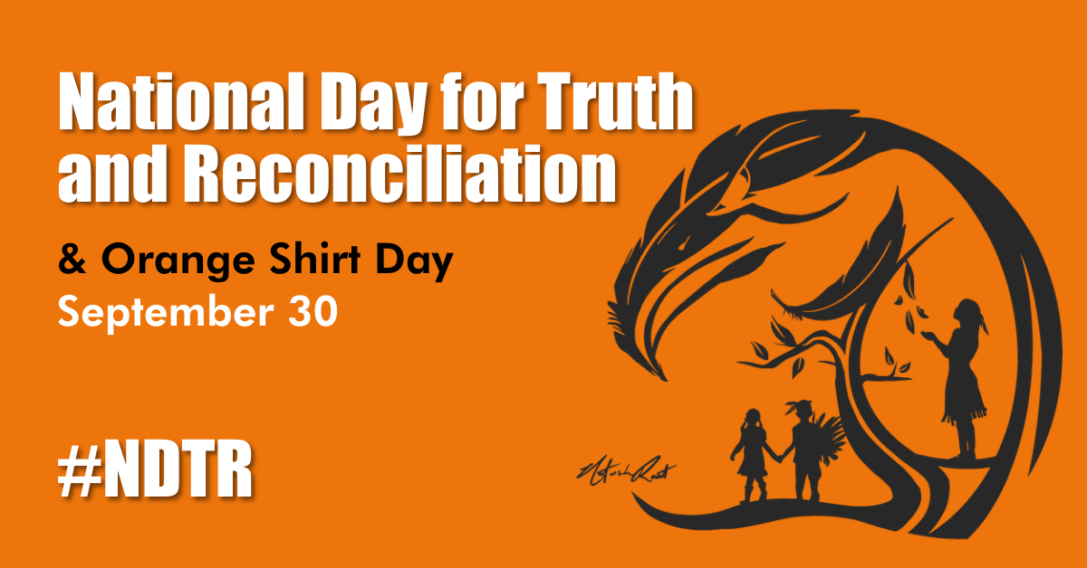 | Gr. 8 Grad Hoodies  Order through Big Bear Spirit Wear  www.bigbearspiritwear.com |  | SCO= School Cash Online
 | 1  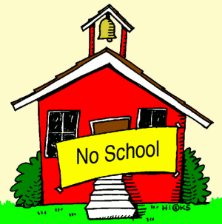  Labour Day  No School | DAY 1 2    First Day of School | DAY 2 3 Terry Fox Walk Donations Open https://schools.terryfox.ca/106673 | DAY 3 4  Lunch Orders Open - SCO | DAY 4 5 | 6
7  St. Michael’s Church  Saturday 5pm  Sunday 10am | DAY 5 8 | DAY 1 9  Athletic Risk Forms Due Gr. 4-8 | DAY 2 10  Junior Soccer Try Outs  Fire Drill | DAY 3 11  Fire Drill | DAY 4 12  Catholic School Council Nomination Forms Due | 13
14  St. Michael’s Church  Saturday 5pm  Sunday 10am | DAY 5 15  Orange Shirts Orders Due – Link in Weekly Update  CSC Meeting 5:30 pm | DAY 1 16 | DAY 2 17  Opening School Mass @ Parish | DAY 3 18  Meet & Greet 5-6 pm  Lunch Orders Close - SCO | 19  PD Day – No School | 20
21  St. Michael’s Church  Saturday 5pm  Sunday 10am | DAY 4 22  Lockdown Drill | DAY 5 23  Journey Retreat Gr.8 |   DAY 1 24  Rowan’s Law Day – Wear Purple  Junior Soccer @ Vale Centre | DAY 2 25 Terry Fox Walk AM  Wear Canada Spirit Wear | DAY 3 26  Alternate Dress Day | 27
28  St. Michael’s Church  Saturday 5pm  Sunday 10am | DAY 4 29 | 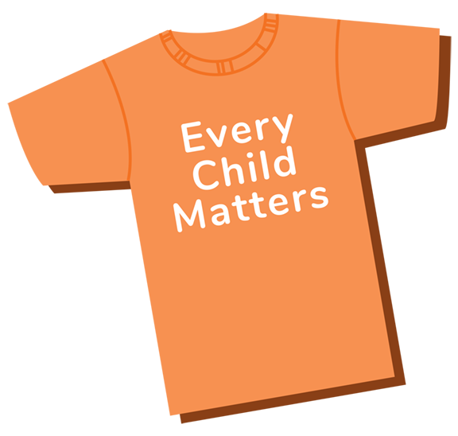  DAY 5 30  National Truth and Reconciliation Day
  St. Michael’s Church  Saturday 5pm  Sunday 10am |   Report all absences prior to 9:00am  Please use the toll-free number, the website, or the SchoolMessenger mobile app to report your child’s absence in advance. https://go.schoolmessenger.ca  The toll free number is: 1 844 287 6287 |  | Supervision: 9:00am School begins: 9:15am  Times  9:00-9:15 am Arrival for Start of School Day  9:15 am Morning Bell  11:25am – 12:05pm Nutrition Break 1 – Eating 11:45-12:05  1:25 – 2:05 pm Nutrition Break 2 – Eating 1:45-2:05  3:20 pm Kindergarten Dismissal  3:35 pm Dismissal |  | CONTACT INFORMATION  Principal: Mrs. A Cybula  1332 Phillips Street, Fort Erie, L2A 3C2  P: 905-871-1842  Email: st.philomena@ncdsb.com  Website: www.niagaracatholic.ca

