

**June, 2025 NEWSLETTER**

**\*\*\*\*\*\*\*\*\*\*\*\*\*\*\*\*\*\*\*\*\*\*\*\*\*\*\*\*\*\*\*\***

**Message from Mrs. Araujo and Mrs. Kish**

And just like that it’s June!! A warm thanks to all families who have supported all of our endeavours this year. Thank you for entrusting your children with us and for all the ways you have worked with us to ensure your children have a successful year. We aim to provide all students with a positive experience and this would not have been possible without you. Take this time to relax and recharge. To our Grade 8 students, we wish you all the best!!

Goodbye to Ms. Moore, Mr. Giammarco, Ms. Roy, Ms. Venneri, and Ms. Wilson. Thanks for being a part of our team this year. We hope to work with you again in the future.

**Faith Matters- June**

In the Bible, Jesus invites us with the words "Come, follow me." This means He wants us to join Him on a journey of love, kindness, and faith. Just like a good friend who shows us how to be our best selves, Jesus is asking us to follow His example. When we help others, show compassion, and make good choices, we're following Him and living the way He taught us. It’s like being part of a special team where everyone works together to make the world a better place. So, when we hear "Come, follow me," it’s Jesus asking us to be His helpers and to spread His love to everyone we meet.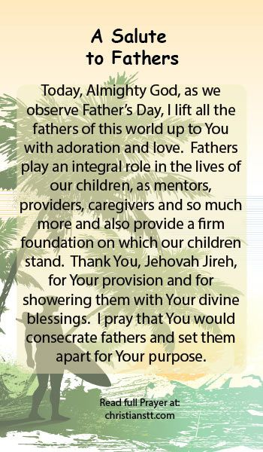

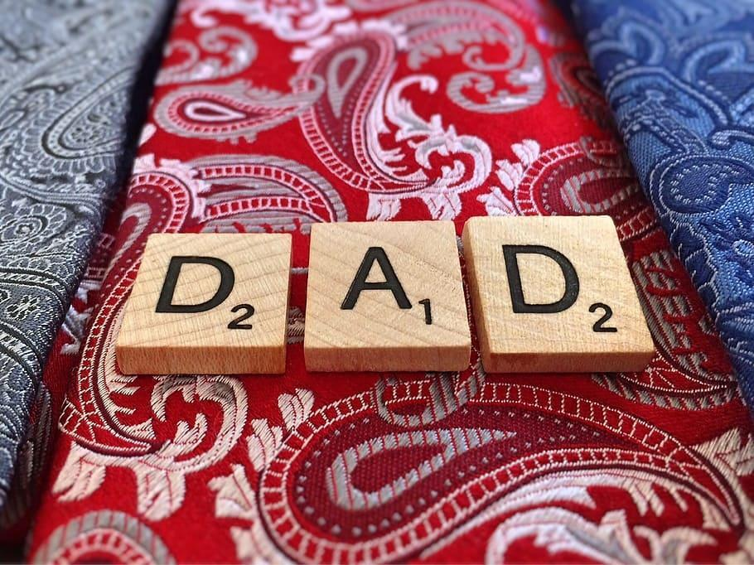

**Term 2 Reports, IEPs and Student Placement**

All student Term 2 reports and IEPs will be sent home on Wednesday June 25, 2025. We encourage you to view these important documents with your children.

**All student placements will be forwarded to families via email the last week of August. Please ensure your email information is up to date**. Following student placements, a subsequent communication will be sent by your child’s classroom teacher. This will provide information on items that may be required for the school year. In the interim, here are some items that you may need according to grade/division:

**Tentative Staff Assignments 2025-2026**

Kinder A- Mrs. Trivieri, Ms. Manson

Kinder B- Mrs. Borsodi (.5) Ms. Barlow (.5)/ Mrs. Krushelnicki

Kinder C-Mrs. DiTomasso, Mrs. Littler

Kinder D- Mrs. James/ (ECE) TBA

Grade 1- Mrs. DiMarco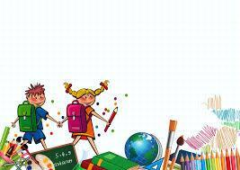

Grade 1- Mr. Anzovino

Grade 1/2 - Ms. Kavai

Grade 2- Ms. Marchese (Karen)

Grade 2- Mrs. Zortman (Kim)

Grade 2/3 - Mrs. Pijl

Grade 3- Mrs. Haitas

Grade 3/4- Mrs. Kitchingman

Grade 3/4- Mrs. Savage

Grade 4- Mr. Jaski

Grade 4/5- Mrs. DeBellis

Grade 5- Mrs. Cantoni

Grade 5/6- Mr. Puma

Grade 6- Mr. Boland

Grade 7- Mr. Grossi

Grade 7- Mr. Sorgini

Grade 7 - Mr. Ciccone

Grade 8- Mr. Martinelli

Grade 8- Mr. Lettieri

FSL and PTM- Mrs. Ruggiero, Mrs. Fthenos and Mrs. DiIanni

ERT- Mrs. DelGobbo Hanounik, ERT .5- Mrs. Borsodi

EAs- Mr. Blake, Mr. Finlayson, Ms. Gillis, Ms. Chantler, Ms. Jeffrey, TBD

Library Technician- Mrs. Barfield

Secretaries- Mrs. Procaccini and Ms. MacDonald

Head Custodian- Mrs. Gibson, Caretakers- Ms. Yablonsky and Mr. Dryce

Vice-Principal- Mrs. Kish

Principal- Mrs. Araujo

**Class Placements for September 2025-2026- IMPORTANT PLEASE READ**

In the weeks and months ahead we will begin organizing our school for the upcoming school year. Teachers and support staff will dialogue and determine where each child needs to be placed to best meet their needs and ensure success. Similar to last year, we are providing parents with the opportunity to place their requests in for their children. **ALL REQUESTS WILL NEED TO BE MADE VIA THIS GOOGLE FORM -** [**https://forms.gle/pGkeZx22xUNvVDdBA**](https://forms.gle/pGkeZx22xUNvVDdBA)**.**  Please do not provide this information to the classroom teacher or via email. All class placement requests will be centrally located. If you are having difficulty accessing the link, please email the school.

**Due to the number of requests we had last year, we are asking that parents limit their requests to TWO per child.** We have also removed the option of asking to NOT be placed with a teacher. We feel that all of our teachers are qualified staff members who have only the best interests of your children in mind. We hope you understand. However, you can ask to be placed **with** a certain teacher.

**All requests must be made using the Google form no later than May 31, 2025**. Any requests made after this date will not be entertained. Please understand that creating class lists for this size of a school is a huge undertaking and one that we take very seriously. It is very difficult to make changes last minute as it affects many other classes, teachers and students. Your understanding is anticipated and appreciated.

**NEW YEAR SUPPLY SUGGESTIONS:**

| Kindergarten | Primary 1-3 | Junior 4-6 | Intermediate 7-8 |
| --- | --- | --- | --- |
| * a change of clothing in a clear plastic bag (top, pants, underwear, socks)--all labeled - very important and kept at school * Indoor running shoes (Velcro) * Backpack (regular size) * lunch bag * reusable water bottle * Reusable cutlery * 2 packages of dry-erase whiteboard markers * 1 box of 8 washable markers * 1 box of sharpened pencil crayons or twistables * 2 boxes of tissues * 1 package of wipes * 1 box of large ziploc bags * 3 large glue sticks * 3 cans of Playdough * Craft donations (gems, sparkles, pom poms, googly eyes, etc.) | * A large backpack * A change of clothes **labeled** in a ziploc bag (dress code top, pants, underwear, socks) * Lunch bag * Indoor running shoes (**Velcro**) * 2 boxes of tissues * 1 package of wipes * Reusable water bottle * 3 dry-erase markers * Small dry erase board & eraser * Several sharpened pencils * eraser * 1 box of sharpened pencil crayons or twistables * Pencil sharpener with shaving case * 1 box of washable markers * 4 large glue sticks * 2 cans of Playdough * A pencil case * 2 large ziploc bags * A personal set of headphones or earbuds for iPad/ Chromebook use. | * Indoor shoes * Pencil crayons * Pencils * Highlighters * Glue stick * Small enclosed sharpener * Red pen * Small pencil case * Small agenda/calendar * Box of tissues * Calculator * Ruler (30 cm) * Black Thin tip Sharpies * A personal set of headphones or earbuds * 30cm ruler * markers * French: thin binder or plastic duotang that has pockets on the inside to hold loose papers with lined paper in the binder | * Scientific Calculator * Indoor/Running Shoes * Personal Chromebook if available * Personal hygiene products for locker (deodorant, etc) * Two 2” medium sized binders (Gr.8) * Standard school supplies * French: thin binder or plastic duotang that has pockets on the inside to hold loose papers with lined paper in the binder |

**Grade 8 Graduation**

We wish our Graduates all the best as they complete their Elementary years and begin the next phase of their educational journey. We have so enjoyed having you a part of our family and we can’t wait to see what the future holds for them. We will celebrate our wonderful 8s on Friday, June 20, 2025. The ceremony will take place at St. Joseph’s Church at 5pm followed by a celebration dinner and dance at Galileo Gardens from 7:30 pm - 10:00 pm for students and staff.

**Message from Public Health**

| **Sun Safety** |
| --- |

When enjoying the outdoors and getting some natural Vitamin D, Public Health would like to remind kids and adults to use proper protection from the sun.

∙ **Slap** on a hat

∙ **Slop** on sunscreen

∙ **Slide** on sunglasses

∙ **Slip** on protective clothing

Check out The Canadian Cancer Society's Enjoying the Sun for sun safety tips and information on protecting toddlers and children.

For additional information, visit Niagara Region Public Health’s website.

| **Screen Time** |
| --- |

As we prepare to head into summer vacation and more time at home, we encourage families to take the opportunity to review recreational screen time and online safety. Over the summer break, there may been increase in children using screens for recreational purposes.

Here are a list of tips to help limit screen time:

**1. Start a Conversation:** Try to understand what family members like and don’t like about using screens.

**2. Model Healthy Habits:** Pay attention to your own screen use, and think about what messages you’re sending. You can also develop a family screen plan to show that managing screen time is important for everyone, not just kids.

**3. Establish Screen Free Time:** Consider setting limits around screen time and establishing certain times and places as no-screen zones. It may be helpful to keep screens out of bedrooms and away from the dinner table. Turning screens off an hour before bedtime is part of a healthy sleep routine and no screens at the table may encourage more quality conversation.

**4. Encourage screen-less activities:** Finding creative ways to keep off screens can be hard when so much entertainment can be found on screens. Discuss as a family how each member can reduce recreational screen time. What screen-less activity can you enjoy as a family? It can be hard to break screen habits, keep each other engaged and accountable!

**Resources**

Are you Web aware? A checklist for kids ages 9-12 | MediaSmarts

Managing Screen Time with your Pre-Teen - YouTube

Family Media Plan Printable - Institute of Child Psychology

| **Check your Immunization Records and Travel Health Notice** |
| --- |

If you are planning to travel, add these actions to your planning checklist to help make your trip a healthy one.

1. **Make sure you and your children are up-to-date with vaccinations**. Staying up-to-date with vaccinations is important all year round. It is especially important before travelling.

* When travelling, you may be at risk for vaccine preventable illnesses. [Check your immunization records](https://nrph.icon.ehealthontario.ca/#!/welcome) or talk to your health care provider.
* Learn more about [where to get vaccinated.](https://www.niagararegion.ca/health/vaccinations/general/default.aspx) Remember to report vaccinations to Public Health for children 0 – 17 years of age. Report [online](https://www.niagararegion.ca/health/vaccinations/reporting.aspx) or call 905-688-8248 or 1-888-505-6074 ext. 7425

1. **Review the Public Health Agency of Canada’s** [**travel health notices.**](https://travel.gc.ca/travelling/health-safety/travel-health-notices) These notices outline potential health risks to Canadian travelers and ways to help reduce them. Stay informed as you plan your travel.

| **Ticks** |
| --- |

Ticks, mosquitos and rabid animals can be a risk as the weather warms up.

* Mosquitoes transmit the [West Nile virus](http://www.niagararegion.ca/living/health_wellness/wnv/) to humans after becoming infected by feeding on the blood of birds, which carry the virus.  To learn how to protect your family, visit [Reduce the Risk of West Nile Virus - Niagara Region](https://www.niagararegion.ca/living/health_wellness/wnv/prevent-west-nile.aspx).
* The black- legged (deer) tick transmits [Lyme disease](http://www.niagararegion.ca/living/health_wellness/disease-prevent/lyme-disease.aspx) to humans after becoming infected by feeding on the blood of small animals which carry the disease. To learn how to protect you and your pets, visit [Protect and Prevent Ticks - Niagara Region](https://www.niagararegion.ca/living/health_wellness/disease-prevent/ticks/default.aspx).
* [Rabies](http://www.niagararegion.ca/living/health_wellness/disease-prevent/rabies.aspx) is transmitted through saliva from bites and scratches, entering an open cut or wound, or from saliva contacting a mucous membrane, such as those in the mouth, nasal cavity or eyes.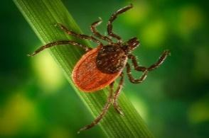

For more information and [tick identification](https://www.niagararegion.ca/living/health_wellness/disease-prevent/ticks/remove-and-test.aspx), individuals can contact a Duty Officer directly at 905-688-8248 ext. 7590. General tick information can be found on our [Niagara Region Public Health website](https://www.niagararegion.ca/living/health_wellness/disease-prevent/ticks/default.aspx).

| **Head safety – for bikes and other wheels** |
| --- |

With warmer weather and summer break just around the corner, more kids will be outdoors taking part in activities, such as biking, skate boarding or roller blading. A [properly fitted and correct helmet](https://parachute.ca/en/injury-topic/helmets/helmets-for-bicycles-inline-skating-scooter-riding-and-skateboarding/) can cut the risk of a serious head injury by up to 85%. This means four out of five brain injuries could be prevented if every cyclist wore a helmet.Parachute Canada's 2V1 Rule.
A person wearing a green bicycle helmet illustrating the proper helmet fitting.
The helmet should cover the top of the forehead and should rest about two fingers’ width above the eyebrows. 
Side straps should fit snugly around each ear in a “V” shape. 
Buckles on the side strap should fit right under the ear. Buckle the chin strap. Tighten it until you can fit only one finger between the strap and your chin. 

* Bike [helmets](https://parachute.ca/en/injury-topic/helmets/helmets-for-bicycles-inline-skating-scooter-riding-and-skateboarding/#helmets-that-are-safe-to-use) should be replaced after five years **or** a crash where the cyclist has hit their head
* It’s not safe to use a [second-hand helmet](https://parachute.ca/en/injury-topic/helmets/helmets-for-bicycles-inline-skating-scooter-riding-and-skateboarding/#helmets-that-are-safe-to-use)
* Baseball hats, big hair clips and headphones should never be worn under a helmet

The human skull is just approximately one centimeter thick, so it is important to remind children to always protect their head when being active. To make sure a helmet fits right, follow the 2V1 Rule (image courtesy of [Parachute Canada](https://parachute.ca/en/))