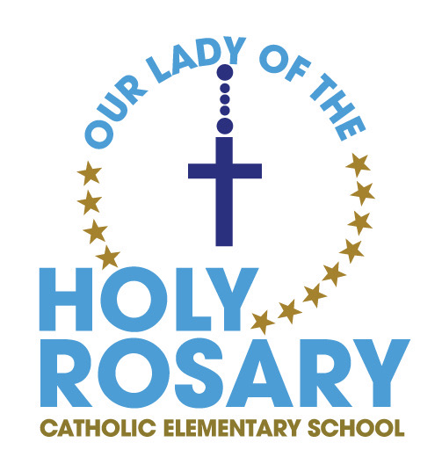

AGENDA / Minutes
Our Lady of the Holy Rosary CSC Meeting

Monday February 3, 2025
6:00PM

A. ROUTINE MATTERS
1. Opening Prayer / Land Acknowledgement – C. Zanuttini
2. Roll Call (regrets) – M. Wilson / E. Cicchino / R. Rotundo
Present – Christine P., Debbie, W., Olivia O., Marci M., Amber M., Cristina N., Joe T., Chris Z.
3. Approval of the Agenda – by Debbie
4. Disclosure of Interest
5. Approval of Minutes of the OLHR Catholic School Council Meeting – November 4, 2024

B. PRESENTATION
1. Policies being vetted: (Please submit any feedback to Jennifer Pellegrini @ CEC)
a. Trustee Code of Conduct;
b. Trustee Electronic Meetings;

C. PRINCIPAL’S REPORT
- Niagara Catholic Parent Involvement Committee (NCPIC) Report – nothing to report
- Special Education Advisory Committee (SEAC) Report – nothing to report
- Catholic School Council Financial Report
- Other updates – updates from C. Zanuttini / J. Tolomeo
Construction set to begin shortly – a workspace will be set up and the exterior of the school will be refaced with masonry. Start at the gym side, and work all the way around the school. Will look sharp.
Also, in the main area of the school, WIFI is not good, so WIFI boosters will be installed.
Look back – the Santa Clause parade hot chocolate sales were successful due to the community aspect. And the cold weather and the location was perfect. Being part of the community.
Intramurals on underway – grade 4-8. Intermediate boys basketball team made it to the finals of the tournament
Robotics club, knitting club, chess
Toronto Maple Leafs KoC raffle
Korean students came and left and had a good experience
Mrs. Sheard will run the Cobbs bread fundraiser for the nutrition program
March 4 – Shrove Tuesday – IHOP will donate
May put a call out for parent volunteers to help for pancake Tuesday
Chromebooks were purchased for the school
Kindergarten Open house and Registration – 36 registrations so far
Kids Helping Kids – themed out of dress code days

D. OAPCE REPORT -

E. STAFF REPORT – Great staff, working hard. Gr. 2s and 5s have outdoor education trips upcoming. Groundhog Day, 100th day coming up, Valentine’s Day, gr. 2s have a prayer service weekly. Juniors working on their book publishing.

G. AGENDA ITEMS-DISCUSSION FOR FUTURE MEETINGS

- - Ideas for September open house
- - planning for purse bingo – maybe a goal for next year – permits etc.
- committee can be organized and meet

H. NEXT MEETING – April 7

I. ADJOURNMENT

⨪

