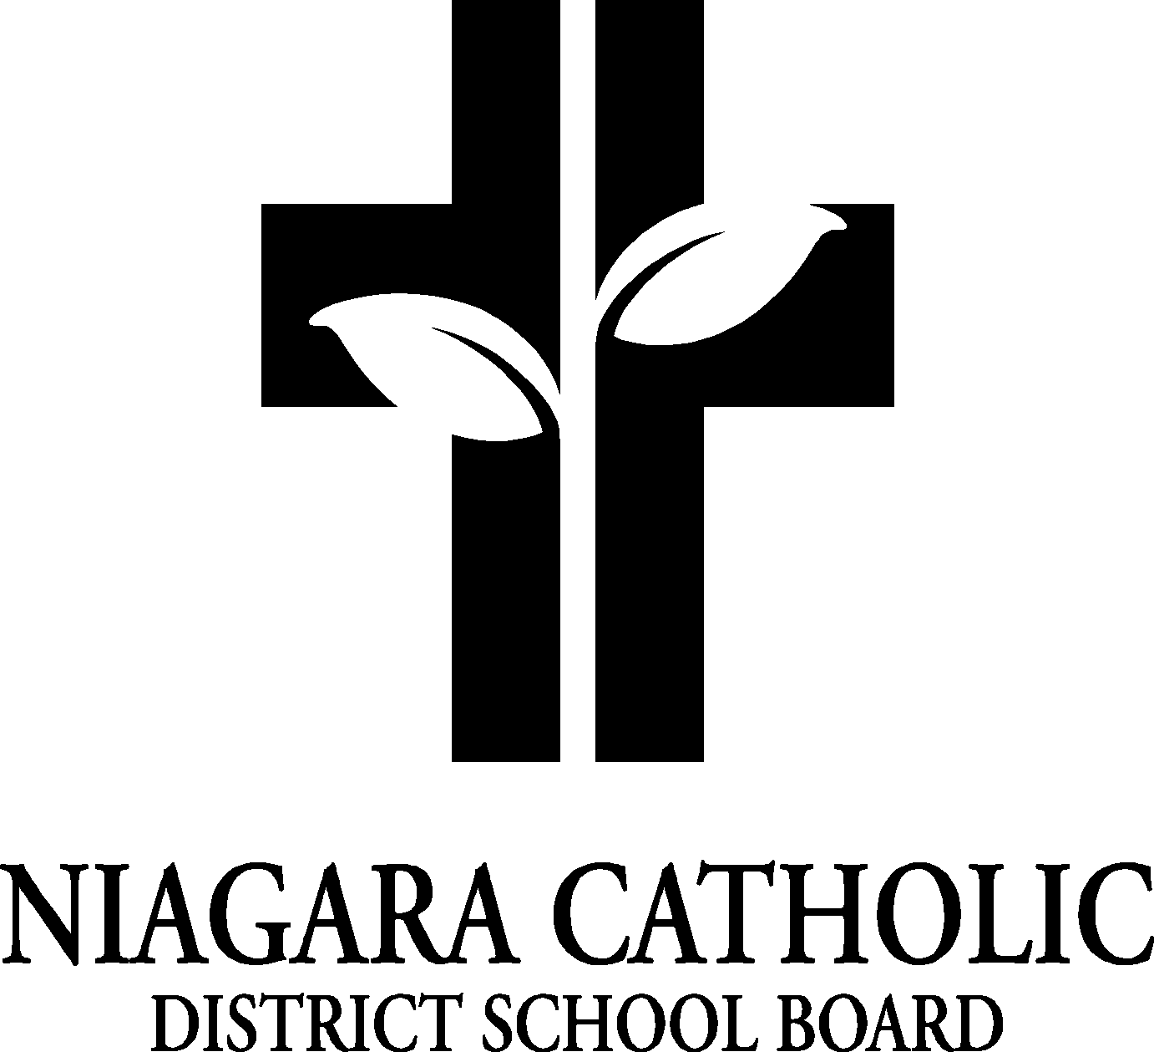

ST. VINCENT DE PAUL CATHOLIC
SCHOOL COUNCIL AGENDA
November 4, 2024 @ 5:30 p.m.

ROUTINE MATTERS
- Opening Prayer – Mrs. Shalala
- Roll Call – Mr. Romano, Mrs. Rosano, Mrs. Lambert, Mrs. Caroli, Mrs. Ker, Mrs. Mazzotti, Mrs. Cordeiro, Mrs. Rizzi, Mrs. Adelstein, Mrs. Gupta, Mrs. Fadell, Mrs. Zahn, Ms. Cullen, Mrs. Salvo-Teutenberg, Regrets: M. Zimmerman, A. Spadafora, K. Prychidney., Mrs. Escobar, Mrs. Aslop, Mrs. Clark, Mrs. Condini-Martin, Mr. Wales, Mrs. Stone
- Approval of the Agenda – Mrs. Zahn, Mrs. Shalala
- Disclosure of Interest - None

BI-LAWS/POLICY ANNUAL REVIEWS
- Board By-Laws Policy (100.1)
- Trustee Expenses and Reimbursement Policy (100.13)
- Complaint Resolution Policy (800.3)
- Please submit your feedback to anna.pisano@ncdsb.com by 12 p.m. on November 20, 2024

PRINCIPAL’S REPORT

- EQAO Results from Spring 2024- Every spring, the Grades 3s and 6s write a provincial assessment in Reading, Writing and Mathematics. We are above board average and above provincial standards. Our results are posted on the EQAO website. The results are the percentage based on students that achieve Level 3 and Level 4 together. In Grade 3, our results are: Reading - 100%; in Writing – 95% and in Mathematics – 95%. In Grade 6, Reading – 100%, Writing – 100% and Mathematics – 85%.
- NCPIC Report- Mrs. Rosano has a meeting on November 11. She will email an update.
- OAPCE Report- OAPCE is the Ontario Association of Parents in Catholic Education. It is in its 86th year. It is trying to help parents with engaging content and resources. They have a book nook that has many resources available to parents.
- SEAC Report- This is a Special Education Advisory Committee that meets at the board office once a month. All the services have a representative.
- Epi Pen Refresher for Staff- Today the school nurse came in to complete an in-service at our staff meeting. This ensures everyone is well versed in using an Epi-Pen.
- Picture Re-Take Day- This Friday, November 8, 2024. Students in Mr. Spiotti and Mrs. Mascia’s class will be having their class photo taken that day. Any students that were absent or would like a retake, they are able to do so.
- Bullying Awareness and Prevention Week- November 21 is our assembly. Miss Botell is planning our assembly.
- Recent School Purchases- Krispy Kreme – we were able to purchase 10 Chromebooks (along with some board funds), 16 brand new volleyballs were purchased. Some outdoor equipment was also purchased for each class to use during recess outdoors.
- Math Achievement Action Plan- Every year, a principal has create a plan based on our EQAO results. Our plan has been set. We would like to see every teacher use instructional mathematic routines in their classroom (i.e. Math Talks). There are 6 instructional routines. They have been laid out in our mathematics SCOEP and SEQUENCE. They are embedded with Knowledgehook and MathUP.
- OLOSC Stuffies- They have partnered up with a lady who crochets November 14, 19 and 20. They are $8.00 and $3.00 go directly to the Church.
- Project Plaid- Project Plaid is an initiative on November 28. This started with a mom who lost her daughter to suicide and wanted to do something to commemorate her daughter as well as create awareness for Mental Health. She started this initiative to raise money for Mental Health and Awareness. Last year we wore plaid and created a plaid basket and sold tickets to raise money. This year we are going to relate it to an out of uniform day. The students can come dressed as one of the Zones and for a $2.00, they can wear a uniform and watch Inside Out movie. All proceeds will go to Pathstones Mental Health. Classroom teachers will also be doing activities that week leading up to the Plaid Project.
- Progress Reports and Alternative IEPs- They will be available on the Parent Portal on Tuesday, November 12 for parent viewing.
- Parent/Teacher Conferences- School Messenger was sent out through School Appointments. We are encouraging parents of more than one child to leave a space in between. There are only 24 slots. The link is not working directly. You can copy and paste it in to the browser and it will work.
- Safe Schools: Kiss and Ride Changes- It is really busy at the end of the day. We are going to try a new idea. We are going to continue with the staggered with 2:40 to 2:50; A through M, 2:50 to 3: N to Z.

FINANCIAL REPORT
- $2280.30 in our food account but we still need to pay our providers. We are about $1000 in profits.

STAFF REPORT
- Cross Country Meet- Coached by Mrs. Teutenberg and Mr. Porga - Thank you to the entire Cross Country Team for an outstanding performance at the Niagara Falls Cross Country Meet on Wednesday, October 9th, 2024. Unbelievable dedication and perseverance was shown throughout the past 3 weeks. Over 25 students from St. Vincent de Paul competed this year, 4 of these students placed in the Niagara Falls Family of Schools Top Ten.
- Royal Canadian Legion Remembrance Day Poster Contest- Teachers have received information about our yearly poster and literary contest through our Local Legion in Niagara Falls. We had many students take part last year and in previous years. Last year we had 4 students win certificates and cash prizes. Teachers have received information and registration packages. If your child is interested in participating, have them reach out to their homeroom teacher.
- Remembrance Day Liturgy- Will be led by Mrs. Mascia and the grade 8 students. It is taking place on November 11th at 10:00 a.m. All parents are invited to attend the liturgy.
- Monthly Mass with Father Greg- Our next school wide mass is taking place tomorrow, Tuesday, November 5th at 9:00 a.m. All are invited to attend.
- St. Paul Transition Visits- The annual St. Paul Pilgrimage recently took place. We had 12 grade 8 students attend with Mrs. Mascia. St. Paul High School, along with their feeder schools raised over $16,000 for their sister school in Haiti. Over $2000 was raised by the elementary feeder schools.
- Gr. 8 Day and Pep Rally took place at St. Paul High School on October 30th. Students had an amazing time meeting new students from other feeder schools and taking part in many fun-filled activities.
- Save the Date – St. Paul Open House for Gr. 8 families is taking place on November 21st at 6:30 p.m.
- Intermediate Volleyball Tournaments- Intermediate Boys Tournament on November 20th at Denis Morris Catholic Secondary School. Team is being coached by Mrs. Mascia. Intermediate Girls Tournament on November 25th at Holy Cross Catholic Secondary School. Team is being coached by Mr. Spiotti.
- Junior Triple Ball Tournaments- Taking place on November 13th. Girls’ tournament at Our Lady of Mount Carmel School. Team is being coached by Mrs. Reich. Boys’ tournament at St. Paul High School. Team is being coached by Mr. Porga.
- #dowhatyoucant monthly assemblies- Next assembly taking place on Nov. 26th.

Dates: December 11 – Family Fun Christmas Night
April 30 – Trivia Night for Adults
May 21 – Delta Bingo – We sell the books here at the school for $25
June 10 – Family Fun Fair
June 18 – Grade 8 Graduation
June 23 – Play Day – Hotdogs and popsicles to all the students at the school.

SUB-COMMITTEE REPORTS

- Beautification Committee- The beautification team worked with the Eco School team to pull weeds and to clean up the front of the school and the sides to get ready for winter. If you have any ideas for beautification, please let Mr. Wales know.
- Graduation Committee- They made over $1100 at the Dance-A-Thon.
- Alternate Lunch Committee- We are booked up until February. There is a company called Healthy Hunger. It is a central site that provides food with local providers.
- Fundraising Committee- Mrs. Homes and Mrs. Lambert – Christmas Fun Fair is December 11. Santa is booked, we have to confirm a time. Letters will start going out soon for the assigned theme basket from each class. In the past, we had students build a gingerbread house and they voted or we can have a Gingerbread Family Night. Grades 1 to 3 will perform songs that night. Theme and what is needed still has to be decided. Keep your receipts and hand them in. We need to get some ideas for Crafts and we need volunteers. There will be a night to help out with the baskets. They are looking at selling Purdy’s chocolates for Easter.
- Spirituality Committee- Mrs. Shalala – Church is looking for students to join the Children’s Choir. We received a shut out for all the food our families donated for the Thanksgiving Food Drive. Niagara Falls Community Outreach (Soup Kitchen) will work with the Grade 8 students and their families to help serve soup to the community. There will be a mitten tree at Christmas. In the past we have donated to Project Share. This year we are donating to Socks and Snacks for homeless people (socks and gloves). We can also collect toiletries. In this outreach, the items are for adults. They will collect in December and distribute for January. Christmas Angel Campaign – The Church will set aside 11 angels for St. Vincent de Paul. We ask for $1.00 per child so approximately $25 per gift per angel. We will collect December 1 to December 14 to collect the money. The Rosary Club – will probably be weekly.

AGENDA ITEMS – Nothing at this time.

NEXT MEETING – Monday, January 13, 2025 @ 5:30 p.m.

ADJOURNMENT - 6:36 p.m.

CLOSING PRAYER – J. Romano, Ending Closing Prayer.

