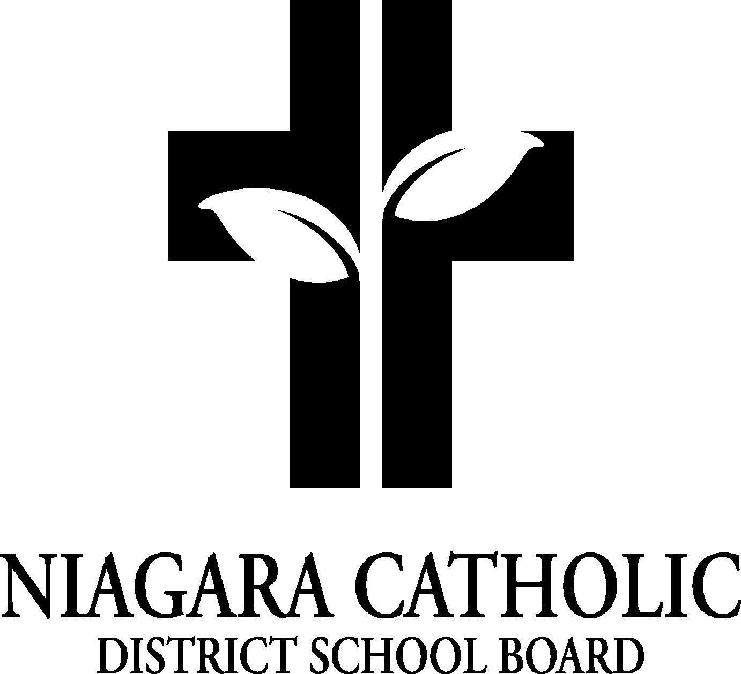

AGENDA
ST. JOSEPH CATHOLIC SCHOOL COUNCIL MEETING
LIBRARY-Monday, January 11, 2016

A. ROUTINE MATTERS

1. Opening Prayer
2. Roll Call
3. Approval of the Agenda
4. Disclosure of Interest
5. Approval of Minutes of the St. Joseph Catholic School Council Meeting of November 30

B. PRESENTATIONS
1. Bingo-as per Kelly DiLapo (new dates January 22 (6-8), February 19th (6-8), March 9th (6-8), March 27 (4-6)
2. Nutrition-Sandy/Karen
3. Garden/ECO-
4. 7/8 Fundraising Sub-Committee

C. PRINCIPAL’S REPORT

- Niagara Catholic Parent Involvement Committee (NCPIC) Report
- Special Education Advisory Committee (SEAC) Report-SEAC news sent home with January calendar
- Catholic School Council Financial Report
- ELKP –Open House/Grade 9 Open House and Registration
- Cash –on-Line
- Pancake Tuesday
- Junior Literacy Day, no spelling bee
- Parish Council-first Tuesday of the month (book hall availability)
- Chrome Books (550.00-Silent Auction Fundraiser)
- Niagara Catholic Education Award of Distinction/Distinguished Niagara Catholic Alumni nominations

D. OAPCE REPORT-Karen Martens (probably no report)
E. STAFF REPORT/student report

F. AGENDA ITEMS-DISCUSSION FOR FUTURE MEETINGS
G. NEXT MEETING
H. ADJOURNMENT
I. CLOSING PRAYER

