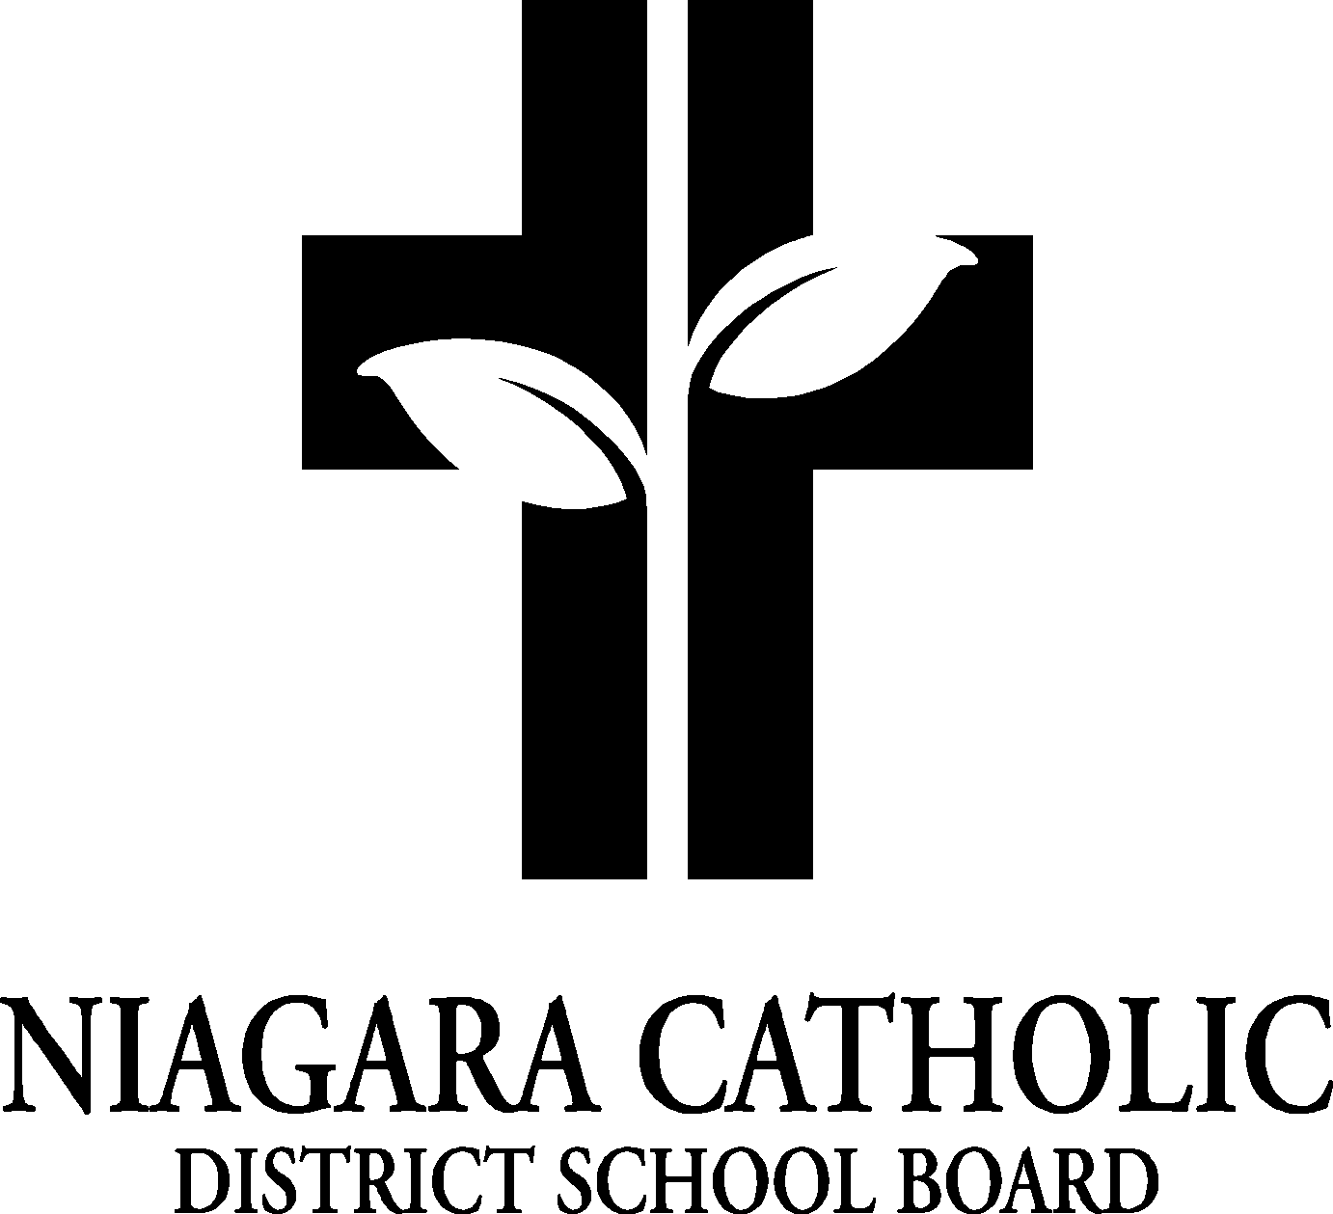

**ST. VINCENT DE PAUL CATHOLIC SCHOOL COUNCIL AGENDA**

**November 9, 2022 @ 5:30 p.m.**

1.  **ROUTINE MATTERS**
2. Opening Prayer – A. Attree
3. Roll Call – J. Romano, L. Rosano, B. Wales, V. Hantziagelis, F. Conidi-Martin, A. Attree, A. Holmes, S. Orsini, K. Zahn, S. Salvo-Teutenberg

Regrets: A. Spadafora, R. Lyachovics, B. Lambert

1. Approval of the Agenda – A. Attree, B. Wales
2. Disclosure of Interest – B. Wales for Food Inspection so to be aware there may be a conflict with food.
3. **PRESENTATIONS –** Gino’s Pizza (Mike Rizzo)
4. **PRINCIPAL’S REPORT**–

* Bi-laws/policy Annual Review
* Retirement and Service Recognition Celebration Policy (201.2)
* Volunteer Recognition Policy (800.4)
* Please submit your feedback to Anna Pisano by November 23, 2022 - 12:00 p.m.
* EQAO Results – Grade 3 results: Reading scores 95.6 scored Level 3 or 4, Writing 78.2% Level 3 or 4, Mathematics: 82.6% scored Level 3 or 4. Grade 6 results: Reading Score: 100% scored Level 3 or 4; Writing Score: 100% in Level 3 or 4, Mathematics: 75% scored Level 3 or 4.
* NCPIC Report – Father Paul is the Bishop’s representation. A. Attree would like all the Parents on council to receive their newsletter Connections. There is a Niagara Falls member on OAPCE. Camillo Cipriano came to speak to the group.
* OAPCE Report –
* SEAC Report – Every major organization has a seat. R. Attree represents Autism Ontario. Ready Willing and Able – if you know someone who has a large business and they are looking for employees with a small or large disability, but they help bridge the gap. Contact R. Attree if you have any questions. 2 Goals: Improve transition into all schools with disabilities, even if they are higher functioning. 2. To Improve and gain access to professionals and paraprofessionals outside the NCDSB.
* HB/HPV Vaccines – December 1 for grade 7 and 8 students.
* Epi Pen Refresher for Staff– School Nurse will come this month and train staff throughout the day.
* Niagara Nutrition Partners – It has started this month. They give us an allotment to buy nutritional snacks for the students. Right now we have a bin in each classroom. They fill it up with cheese strings, clementines and granola bars. We are putting a few in each one. Mrs. Zahn spoke to each class about the snacks. They are for everyone.
* Rocks and Rings – December 2nd. Curling inservice at the school gym. They review terminology and scoring. JK to Grade 8
* Ice Dogs – December 7 to do a presentation. They speak about their philosopjhy. December 8th will be our Ice Dogs night for tickets to the game. There will be a shout out on the jumbo tron. There is a preskate an hour before.
* Progress Reports and Alternative IEPs– Progress reports will be on the portal with Alternative IEPs.
* Parent/Teacher Conferences – Correspondence will be sent home Monday for Parents to make appointments with teachers. Nov. 22 from 3:30 to 6:30.
* Lockdown drill - was a success. We did a hold and secure and a lockdown.
* Chaplaincy Visits – Two board chaplaincy team members came to work with each class and teachers received Professional Development during the day.
* Christmas Card Fundraiser – Parents could order Christmas Cards drawn by their students.

1. **FINANCIAL REPORT –** Mrs. Scodellaro printed an updated finance.Alternate lunch days has $3200 in the account. Monster Mash made $751 profit. To Date – Poinsettia’s made $320 to date. Vermeers is the Poinsettia provider.
2. **STAFF REPORT –**

* Food Drive for Grow CFLC – the representative from Grow CFLC came to pick up the food and she was so giddy when she saw the food. She dropped off some literature that we have in the office if anyone wants some more information about their organization
* Holy Childhood Walk – was a great success. The school participated in a liturgy over the PA that included a video that made it nice for the students to see exactly what the Holy Childhood Association does and where the money goes. The students also learned about their motto “Children Helping Children”.
* NSTS Bus Safety – this year’s presentations were held virtually once again. All classes watched the video in their classrooms on their own time. The presentation was excellent as it was interactive, meaning students were engaged and could not proceed until they got the questions to the answers correct. Participation is tracked through NSTS so they know exactly how many students, teachers were involved in the safety training.
* Royal Canadian Legion Remembrance Day Service Fairview Cemetery/ Remembrance Day Liturgy - This year Mr. Spiotti and Mrs Davey along with the grade 6/7 class will be attending the Remembrance Day Service led by the Royal Canadian Legion here in Niagara Falls at the Cenotaph in Fairview Cemetery beside the tomb of the unknown soldier. They will be traveling there at approximately 10:10 am and arriving back to the school at 11:30. Mr. Consoli’s grade 8 class will be leading the rest of the school in a liturgy here in our gymnasium starting at 10:45am. All students will be given a poppy sticker as well to commemorate the day. As always parents are welcome to attend the liturgy.
* Battery Challenge – As part of our Eco Schools initiative, St .Vincent de Paul is collecting old batteries all year. So please send them in with your child so we can fill up our bin and recycled batteries can be properly disposed of.
* Math Up, Lexia, Empower - MathUP is a comprehensive program that helps build teachers’ knowledge and understanding of mathematics so they can better help their students. With a focus on building consistency from grade to grade and increasing each teacher’s confidence in making instructional decisions, MathUP classroom also addresses all expectations in the Ontario Mathematics curriculum.

Lexia - 23 of our students are using the Lexia program. It is an adaptive blended learning program that accelerates the development of literacy skills for students of all abilities, helping them make that critical shift from learning to read to reading to learn.

Empower - 8 of our students are in the Empower reading and decoding program. It's a program developed by sick kids with 25 years of research to get struggling readers to decode larger words and to be able to spell.

* Intermediate Volleyball and Junior Basketball, SVDP Clubs - Intermediate Volleyball Tournaments will be next week and Junior basketball tournaments will be rescheduled towards the end of the month. St. Vincent de Paul is excited to announce the clubs will be starting. Each recess and on a weekly basis, various clubs will be offered to students such as Eco Club, Art Club, Robotics club, Board game Club, Etc.

1. **SUB-COMMITTEE REPORTS -**

* Beautification Committee – A landscaper came in to give us some ideas and to help us make better chocies in landscaping. We want to control the weeds. Landscaping cloth underneath cost 600-700. Weeds would just come back. It becomes a reservoir for seeds and get the same problem. We will discuss other strategies. We can buy porch pots for the front entry way and help the grade 8s at the same time. With the Eco Club, we can get the kids involved.
* Graduation Committee – Monster Mash, Poinsettia – We had a meeting a couple of weeks ago. They are looking at having a Wine Fundraiser. Looking at having the Kernals fundraiser that they sell during recesses. Ceremony will be at St. Vincent de Paul and then decide where to go afterwards.
* Alternate Lunch Committee – Pita Pit did very well. We will have subway coming up soon. Mrs. Rosano is open to any suggestions.
* Fundraising Committee – Theme is Santa’s Workshop - Christmas Fundraiser - December 18, 5-8 p.m. There will be a Santa, hands out candy canes, will take pictures and ends the night with reading Twas the Night Before Christmas. He will be there from 6:30 to 7:30. Activities: Craft table, letters to Santa, selfie station with props. Fruit/cheese platter, baked goods, treats. Each class will donate a basket that is themed based. We have a donation letter that is being reviewed. For the decorations, we thought each class can help with a decorated theme. We will get students to staff certain stations. There will be meetings just for the Fundraising Committee. During that evening, the primary students will be singing.
* Spirituality Committee – We will have a Jesse Tree for Christmas and we will get the students to help make it. Make rosaries for First Communion and Bible covers First Reconciliation. Make Crosses out of psalms. Teach kids how to make them.

1. **AGENDA ITEMS –**
2. **NEXT MEETING – February 8, 2023**
3. **ADJOURNMENT – 6: 55 p.m. Motioned by: A. Attree, Seconded by: Mrs. Holmes**
4. **CLOSING** **PRAYER - A. Attree**