
Niagara Catholic District School Board
VOLUNTEERING IN CATHOLIC SCHOOLS
ADMINISTRATIVE OPERATIONAL PROCEDURES
800 – School & Community Relations | No 800.9
Adopted Date: March 19, 2013 | Latest Reviewed/Revised Date: February 25, 2020

In keeping with the Mission, Vision and Values of the Niagara Catholic District School Board, the following are Administrative Operational Procedures for Volunteering in Catholic Schools.

PREAMBLE

The Board has the responsibility to provide a safe and secure working and learning environment for all students and employees.

A school volunteer is defined as an individual who has direct and regular contact with students of the Niagara Catholic District School Board.

Volunteers are integral to the success of all schools in the Niagara Catholic District School Board and as such are important sources of support and expertise that enrich the instructional program, assist teachers, and connect the student body with the community. Volunteers are valued partners who assist staff in fostering positive relationships and cooperation amongst the school, parents/guardians, the parish and the school community for the benefit of our students.

The personal interests, background and commitment of volunteers enhance the programs, services and education opportunities for our students. Each volunteer will model caring and cooperative relationships, promote our Catholic values, encourage a safe and secure learning and working environment and support the Mission, Vision and Values of the Board and its Policies and Administrative Procedures.

It is the expectation of the Board that all volunteers adhere to Board Policies and Administrative Procedures at all times when volunteering for the school and/or Board events or activities.
In accordance with the Safe Schools Act, all volunteers must be approved by the school Principal. The Principal is authorized by the Board “to assign to a person who volunteers to serve without remuneration such duties in respect of the school as are approved by the Board and to terminate such assignment as required”. (Safe Schools Act, 2000)

Through this Administrative Operational Procedures the Board encourages and promotes the use of Principal approved school volunteers in order to expand and enhance parental and community involvement within our Catholic schools.

- A school volunteer shall serve under the immediate supervision and direction of administration and staff of the school and will provide services such as, but not limited to:
- Supporting the work of classroom teachers
- Providing enrichment experiences to support the educational program
- Promoting positive school-community relations by enhancing community understanding
- Working with individual students and small groups of students as identified by the staff and administration

- The Principal is responsible for:
a) determining the volunteering needs for a school;
b) the recruitment, selection and screening of volunteers;
c) approving and delineating the task and the assignment of the volunteers;
d) the training and orientation of the volunteers;
e) the supervision and evaluation of the volunteers;
g) the recognition of the volunteers.

- Each Principal shall maintain a current list of regular and occasional volunteers. Such records, including the Volunteer Application Form shall be kept on file at the school.

- A volunteer must be at least 18 years of age, unless otherwise approved by the Principal.

- It is understood that a volunteer is a person who serves without remuneration.

- All approved school volunteers (persons having direct and regular contact with students) will provide an original Police Vulnerable Sector Check and/or Annual Offence Declaration in accordance with Regulation 521/01, as amended by Regulation 323/03 to the school Principal who will retain a copy on file at the school until a more current Vulnerable Sector Check is submitted. A copy of the Vulnerable Sector Check will also be forwarded to the Human Resources Department.

- Vulnerable Sector Checks may be requested at the discretion of the Principal in consultation with the Family of Schools Superintendent and at least once every five (5) years. The Self-Offence Declaration will stand as a legally binding document which will be required on an annual basis.

Completed Criminal Reference Checks and/or Vulnerable Sector Checks for volunteers, as well as all subsequent offence declarations will be filed at the school and in the Human Resources Department. Vulnerable Sector Checks required by the Principal and/or the Niagara Catholic District School Board will be paid by the Niagara Catholic District School Board. Any additional requirements as a result of the Vulnerable Sector Checks will be the responsibility of the Volunteer.

- As required, each volunteer shall adhere to the Volunteer Drivers Administrative Operational Procedures (302.4).

- Volunteers shall wear the “Volunteer” badge or other means of identification as required by the school and Board Policy and must sign in/out at the school’s main office.

- Classroom teachers and school administrators are solely responsible for student discipline. Volunteers are to ask for the assistance of the teacher and/or Principal if a situation calls for follow-up disciplinary action. The volunteer always works under the direction of staff.

- Volunteers are responsible for respecting the confidentiality of all students and staff and as such are required to complete the Confidentiality Agreement found within the Volunteer Application Form Volunteers shall not have access to, nor disclose confidential information.

- Off-site activities such as field trips are considered an extension of the school and as such administrative procedures pertain to such activities as determined by the Educational Field Trip Administrative Operational Procedures. At a minimum, Vulnerable Sector Checks will be required of all volunteers participating in overnight field trips which are approved by the school Principal and/or the Board.

- It is the expectation of the Board and the school Principal that all volunteers adhere to Board Policies and Administrative Procedures at all times when volunteering for the school and/or Board events or activities.

References:
- Niagara Regional Police Services:
  - Police Criminal Record Check (PCRC) (Contact Human Resources for form)
  - Police Vulnerable Sector Check (PVSC) (Contact Human Resources for form)
- Regulation 521/01, as amended by Regulation 323/03
- Niagara Catholic District School Board Policies/Procedures/Forms
- Accessibility Customer Service Policy (800.8.1)
- Catholic School Council (800.1) AOP
- Educational Field Trip (400.2) AOP
- Niagara Catholic Parent Involvement Committee Policy (800.7)
- Volunteer Drivers (302.4) AOP
- Volunteer Recognition Policy (800.4)
  - Code of Conduct Policy (302.6.2)
  - Privacy Policy (600.6)
  - Privacy Breach Procedure
  - Annual Offence Declaration
  - Volunteer Application Form

Adopted Date:  Revision History: | March 19, 2013  February 25, 2020

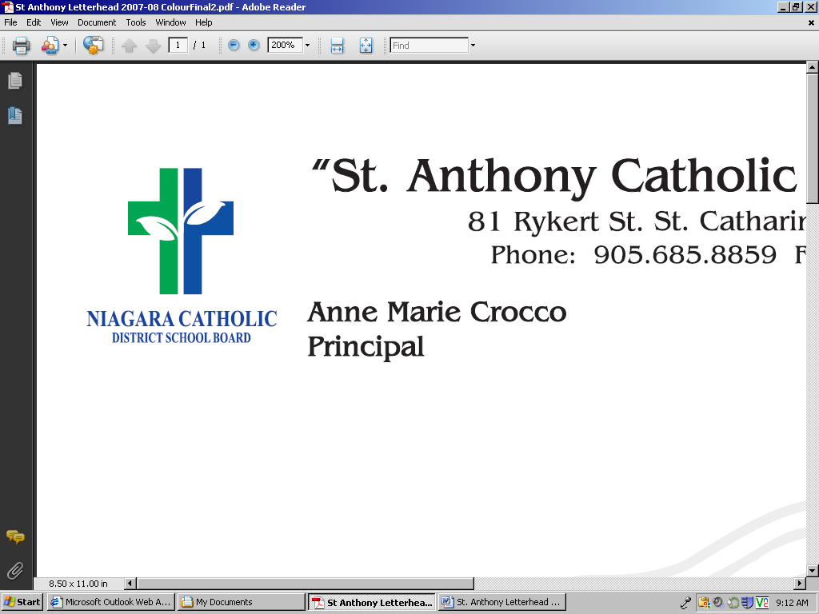

VOLUNTEER APPLICATION FORM

I _________________ wish to serve as a volunteer at __________________Catholic School.

As a volunteer I acknowledge and will adhere to the following expectations:

- As school volunteer I shall serve under the immediate supervision and direction of administration and staff of the school.

- It is understood that I will volunteer without remuneration.

- Completed Criminal Reference Checks and/or Vulnerable Sector Checks for volunteers, as well as all subsequent offence declarations will be completed and filed at the school.

- I will adhere to the Volunteer Driver Policy # 302.4

- Classroom teachers and school administrators are solely responsible for student discipline.

- I acknowledge that in the course of my volunteer work with ______________________ Catholic School I may receive confidential information with respect to the affairs of its students, including information on its students and parents of its students,
- I hereby agree not to disclose at any time, such confidential information to any person, information relating to the students or any part thereof and other information relating to the school or board.
- This agreement pertains to off-site activities such as field trips as an extension of the school.
- As a volunteer I will adhere to Board Policies and Administrative Procedures at all times when volunteering for the school and/or Board events or activities.

- This agreement pertains to off-site activities such as field trips as an extension of the school.
- I have read and agree with the Volunteering in Catholic Schools Policy and Administrative Procedures.

____________________________________ _____________________________________
Principal Signature Volunteer Signature

____________________________________ _____________________________________
Date Signed Date Signed

This information is collected under the authority of the Education Act and in compliance with the Municipal Freedom of Information and Protection of Privacy Act. Should you have questions, please contact the Principal of the school.

