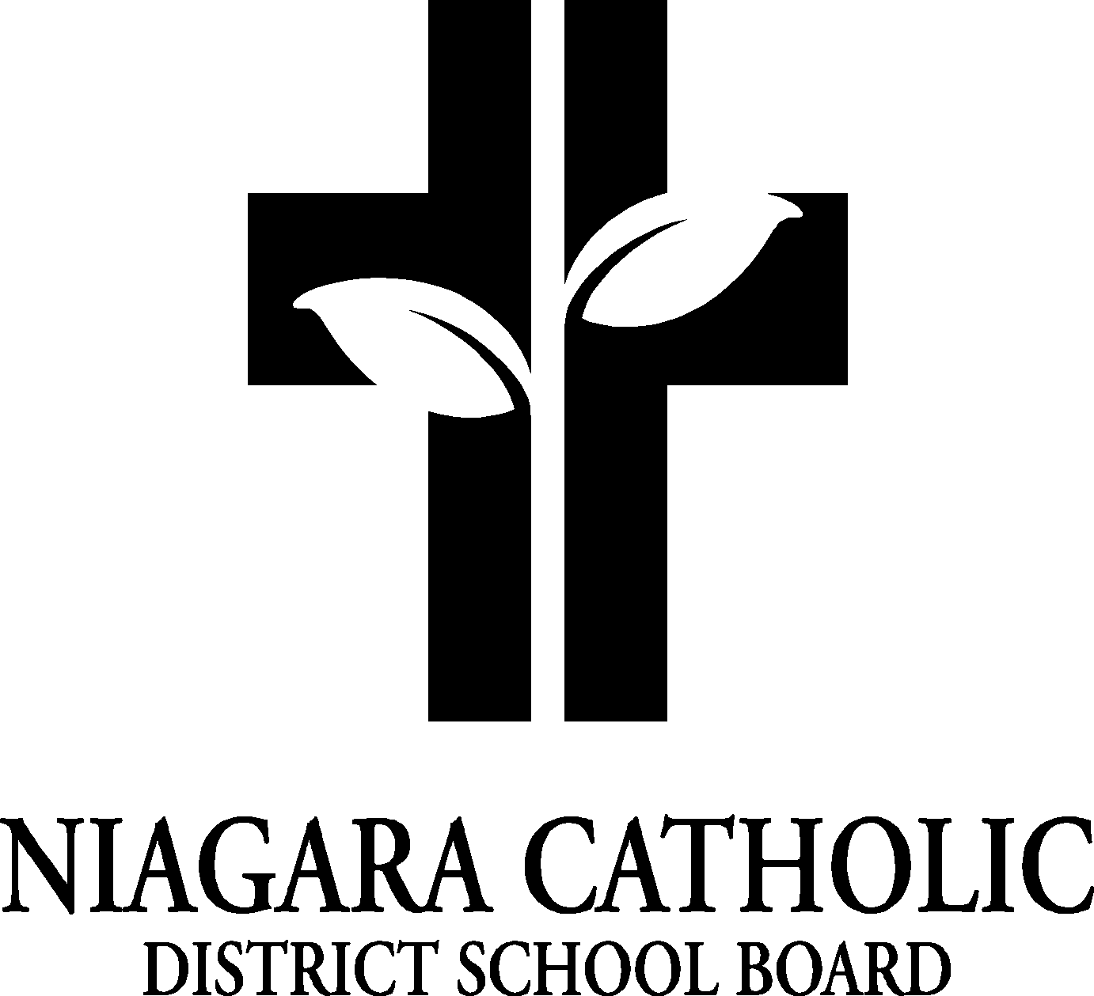

**AGENDA**

**ST PHILOMENA** **CATHOLIC SCHOOL COUNCIL MEETING**

on April 11th, 2022 @ 6:15 p.m.

Via Google Meet: meet.google.com/kkf-rwgp-xob

----------------------------------------------------------------------------------------------------------------------------------------------**A. ROUTINE MATTERS**

1. Opening Prayer-Spagnol
2. Roll Call – Present :

-Carrie Gordon, Diane Lebar, Leah S, Jamie Fiegel, Elizabeth McCooey, David VanKoughnett (late)

1. Approval of the Agenda – Diane Lebar - 1st, Elizabeth McCooey – 2nd approval
2. Disclosure of Interest – n/a
3. Approval of Minutes of the St Philomena Catholic School Council Meeting of February 22nd, 2022

* Diane Lebar – 1st, Elizabeth McCooey – 2nd approval

**B. PRESENTATIONS**

**C. PRINCIPAL’S REPORT**

1. 1. Smart Board Purchase – Mrs. Vacca’s classroom needs a new smartboard as hers is not under warranty. Cost to replace is approximately $3,600. Mr. Spagnol has some funds he can use for it but it will deplete the funds so a fundraiser will need to be held at some point to replenish the fund.

2. Return of School Sports and Clubs – chess club, crochet club, baseball, soccer, and track and field has returned to the school.

3. Catch the Spirit Award Winner: T.F

4. Knowledgehook Full Marathon Recipients: N.M.and D.R.

5. Student Senate Update: Student Leadership Symposium: M.M, E.C. and N.A.-April 28th

6. Stations of the Cross: Thursday April 14th: McCormack is preparing something and it will be a surprise.

7. Funds to support class trips. – costs of trips, including cost of busing, has gone up considerably. A vote was taken to give each student $10 towards the cost of their trip. The vote was unanimously in favor.

2. Niagara Catholic Parent Involvement Committee (NCPIC) Report – n/a

3. Special Education Advisory Committee (SEAC) report – n/a

4. Policy Vetting: Policies are being changed so that the wording is more inclusive.

* [100.10.1 - Religious Accommodation Policy](https://cdn.niagaracatholic.ca/wp-content/uploads/2022/03/100.10.1-Religious-Accommodation-Policy.pdf)
* [201.6 - Occupational Health and Safety Policy](https://cdn.niagaracatholic.ca/wp-content/uploads/2022/03/201.6-Occupational-Health-and-Safety-Policy.pdf)
* [201.7 - Employee Workplace Harassment Policy](https://cdn.niagaracatholic.ca/wp-content/uploads/2022/03/201.7-Employee-Workplace-Harassment-Policy.pdf)
* [201.11 - Employee Workplace Violence Policy](https://cdn.niagaracatholic.ca/wp-content/uploads/2022/03/201.11-Employee-Workplace-Violence-Policy.pdf)
* [201.16 - Attendance Support Program Policy](https://cdn.niagaracatholic.ca/wp-content/uploads/2022/03/201.16-Attendance-Support-Program-Policy.pdf)
* [302.6.8 - Bullying Prevention Intervention Policy](https://cdn.niagaracatholic.ca/wp-content/uploads/2022/03/302.6.8-Bullying-Prevention-Intervention-Policy.pdf)

*Please submit your feedback to*[*Anna Pisano*](https://niagaracatholic.ca/contact-anna-pisano/)*by 12:00 p.m. April 20, 2022*

**D.BINGO REPORT**

1. Opening balance: March 1st : $7653.60

Deposit :  $139.74

Closing balance : March 31st : $7793.34

-No spending to date

-Still waiting on approval of $10,000 budget

-Allocated funds for mats, gym equipment, recess equipment, ect.

**E. CHAIR/ CO-CHAIR REPORTS**

Fundraising Decision: Krispy Kreme, Big Reds, The Mill, etc.

Discussion ensued about each fundraising prospect and it was ultimately decided in a unanimous vote that we would proceed with Krispy Kreme fundraiser. We will need to arrange transportation to pick up donuts.

**F. OAPCE REPORT-** n/a

**G. STAFF REPORT**

1. Passion Play @ OLV:Grade 7 and 8: April 13th
2. Stations of the Cross: April 14th
3. Good Friday; April 15th
4. Easter: April 18th
5. Earth Day: April 22nd
6. Easter Mass @ St. Michael’s Church: April 26th
7. Grade 8 Grad Photos: April 27th
8. Student Leadership Symposium @ Club Roma: April 28th
9. Dress Down Day: April 29th
10. First Communion @ St. Michael’s Church: May 1st @ 1pm

**H. AGENDA ITEMS / DISCUSSION FOR FUTURE MEETING**

1.

**I. NEXT MEETING** – last week in May, 2022. TBD.

**J. ADJOURNMENT –** Jamie F, Elizabeth McCooey

**K. CLOSING PRAYER**



