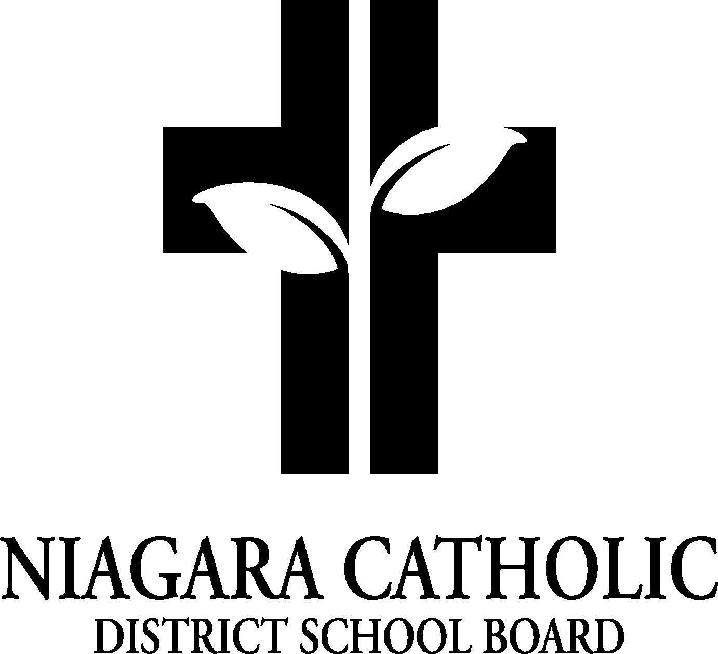

MINUTES OF THE
St. Charles and Monsignor Clancy VIRTUAL CATHOLIC SCHOOL COUNCIL MEETING

January 26th, 2022

Minutes of the Meeting of the St. Charles and Monsignor Clancy Catholic School Councils, held virtually on January 26, 2022 at 6:00pm
The meeting was called to order at 6:00pm by Chris Zanuttini Principal of Monsignor Clancy.

A. ROUTINE MATTERS

1. Opening Prayer

The opening prayer was led by Mr. Zanuttini

2. Roll Call

CATHOLIC SCHOOL COUNCIL MEMBERSHIP |  | Present | Excused | Absent
Principal/Vice-Principal  Secretary/Treasurer | Dan Trainor/ Chris Zanuttini | •
Chair | Franca Milan | •
Co-Chair
Teacher Representative | Tanya Masales, Audrey Weber | •
Non-Teaching Representative | Lucy Lefebvre | •
Student Representative
Parish Representative | Patti McGinnis |  |  | •
OAPCE Representative
PARENT REPRESENTATIVES
Laurie Hebert |  | •
Rosanne French |  |  |  | •
Marci Morandin |  |  |  | •
Melissa Desabrais |  | •
Lana Funk |  | •
Mary Kate Skubel |  | •
Alicia Merry |  |  |  | •
Elizabeth Cicchino |  | •
Meghan Wilson |  | •
Kendra DeGasparis |  |  |  | •
Ian Woods |  |  |  | •
Jeff Maxwell |  | •
Claire Ellsworth |  |  |  | •
Angela Coleman |  | •

3. Approval of the Agenda

Moved by Laurie Hebert
Seconded by Audrey Weber
THAT the St. Charles and Monsignor Clancy Catholic School Councils approve the Agenda of the St. Charles and Monsignor Clancy Catholic School Councils Meeting of January 26, 2022.
CARRIED

4. Disclosure of Interest

Item F.3 – the following individuals are board employees – Audrey Weber, Tanya Masales, Jeff Maxwell, Lucy Lefebvre, Laurie Hebert, Rosanne French

5. Approval of Minutes of the Monsignor Clancy Catholic School Council Meeting of November 25, 2021
Approved by Angela Coleman
Seconded by Laurie Hebert
THAT the St. Charles and Monsignor Clancy Catholic School Councils approve the Minutes of the St. Charles and Monsignor Clancy Catholic School Council Meeting of November 25, 2021.

- PRESENTATIONS
- Policies Being Vetted
The following policies are being vetted:
- Accessibility Standards Policy
Please submit your feedback to Jennifer Pellegrini by February 22nd, 2022

- Principal’s Report
- Niagara Catholic Parent Involvement Committee (NCPIC) Report: Mary-Kate Skubel
Information was shared about the November meeting. The meeting included a Mental Health and Wellbeing presenter. The presenter discussed a 3-year plan for Covid recovery that includes involvement from Child and Youth Workers, referrals for Social Workers, Teen Connect. Each NCPIC member was given a mini package with information. If you would like more information, MK Skubel can email it to you.
At the January meeting, the school calendar for next school year was discussed, as well as a Prolife Speaker will be presenting at the May meeting.
- Special Education Advisory Committee (SEAC) Report: C. Zanuttini – there is no current report from SEAC
- Catholic School Council Financial Report – nothing to report
- Other Updates- Mr. Zanuttini and Mr. Trainor
  - 2022-2023 school calendar- 2022/2023 school calendar is out for feedback. Feedbacks are to be submitted to the board by February 20th, 2022. Next year, the proposal is for our board going to school until December 23rd, and then have a week following New Year. Any parent can go provide their input into the vetting process.

M.K.Skubel mentioned that daycares in the region did not align with the school calendar.
A motion was put forward by Lana Funk that our Catholic School Council be in favour of this calendar proposal. Lucy Lefebvre seconded the motion.
This Catholic Council is in favour of the calendar and coordinating with local daycares.
  - Our Lady of the Holy Rosary construction update- Monsignor Clancy has received occupancy to the new side of the school. Additional custodial staff are coming into clean lockers, staff room etc. The Grade 8’s moved to their new rooms. They have new floors, boards etc. The Grade 7 classes are waiting for technology to be fixed before they move into their new rooms. Grade 7 rooms have had the walls painted and the ceiling tiles replaced. The library and new office are ready. Mrs. Wallis is currently unpacking the books and filling shelves. Phase one of the construction is done. Currently, phase 2 (the daycare) is scheduled to be finished at the end of February. Refurbishing the original part of the school will be next. The board will begin vetting architects for that redesign in the spring.
Arrival and Dismissal to school will pilot a new system. The buses will drop off and pick up at the Sullivan Ave entrance and kiss and ride will continue on Collier Rd.
New chapel can hold one class at a time. The chapel is near the new front doors.
The new daycare will be a three-tiered daycare (in the old office area), as well as provide before and afterschool care in current classrooms. The provider will be the current YMCA daycare.
Registration for Kindergarten can occur at any time. They already have 18 registrations for September
  - Weekly Advent celebrations during Advent- throughout the course of Advent there were weekly advent celebrations, and one mass from Father Michael. The prayer services were led by the older students at Monsignor Clancy
  - Term 1 Reports and IEP’s – Both report cards and IEPS will be available the week of February 22nd via the parent portal. Any interviews will be scheduled between staff and parents.
  - Legacy Hoodies- a sample of the OLHR logo was shared. Most designs include female angels. They have blended the cross with angel wings. The writing of Guardians will be written in a specific print. As soon as the photographer has completed a template, it will be emailed to Franca. The legacy hoodies will be offered to all students. Legacy hoodie will have the new logo and the crusader and penguin logos.
3 vendors will be vetted for pricing. A t shirt option can also be provided as well.
There may be opportunities to also purchase other merchandise including t shirts, masks, golf shirts There are quite a few options available from vendors.
  - Shrove Tuesday/ Ash Wednesday – due to Covid protocols we will unfortunately not be having Shrove Tuesday pancakes. For Ash Wednesday Father Michael will deliver, blessed ashes. Staff will follow protocol for administering the ashes.
  - Valentine’s Day routines – Children can bring in Valentine’s. Sharing between other cohorts can’t occur. However, students would give the valentines to the classroom teacher who will give them to the student. No food products to be brought in. This information will be shared in the newsletter.
  - Kids Helping Kids – St. Charles and Monsignor Clancy will participate in the 2-week campaign for the Niagara Peninsula Children Centre. Various events will be planned. Some possibilities include a Canadiana day to go along with National Flag Day. Other possibilities include Accessorize your dress code day. Fun activities will be planned to celebrate this great campaign.
Online donations for Kids Helping Kids will be available for families who wish to contribute. Respecting hard times – we are going to attempt to get hot lunches running. The proceeds from the last 2 Wednesdays of February’s hot lunches will be given to the Kids Helping Kids campaign.
  - Holy Rosary Parish Report – Learning and Prayer Sessions are continuing online for First Communion and Confirmation. This year first communion group have students from Grades 2, 3, 4, 5. Very exciting.
- OAPCE REPORTS – no update

- STAFF REPORTS
Covid – no extra curricular activities. Grade 5 robotics starting, and the students are reading Holes. Grade 6 working on electricity unit. Grade 8’s are preparing for Confirmation. Grade 4’s are coming to the end of their first Social Studies unit and will begin a new Science Unit – Light and Sound.
Grade 8’s grad photo deadline has been extended,
- Hot Lunches – the hope is to start hot lunches on February 16th. First lunch would be Coate’s Kitchen. Support local business. He is a former student. He is offering subs. There will be limited options and topping choices. (3 sub options and standard toppings). The last Wednesday – Pete’s Pizza. 2 triangle slices in individual boxes. $4. The goal is to eventually have hot lunches for every Wednesday.

Agenda Items for Future meetings – nothing

- NEXT MEETING – April 27th, 2022
- ADJOURNMENT
Moved by Jeff Maxwell
Seconded by Audrey We
THAT the January 26th, 2022 meeting of the St. Charles and Monsignor Clancy Catholic School Councils be adjourned.

This meeting was adjourned at 6:44 PM.

- CLOSING PRAYER was led by Mr. Trainor

