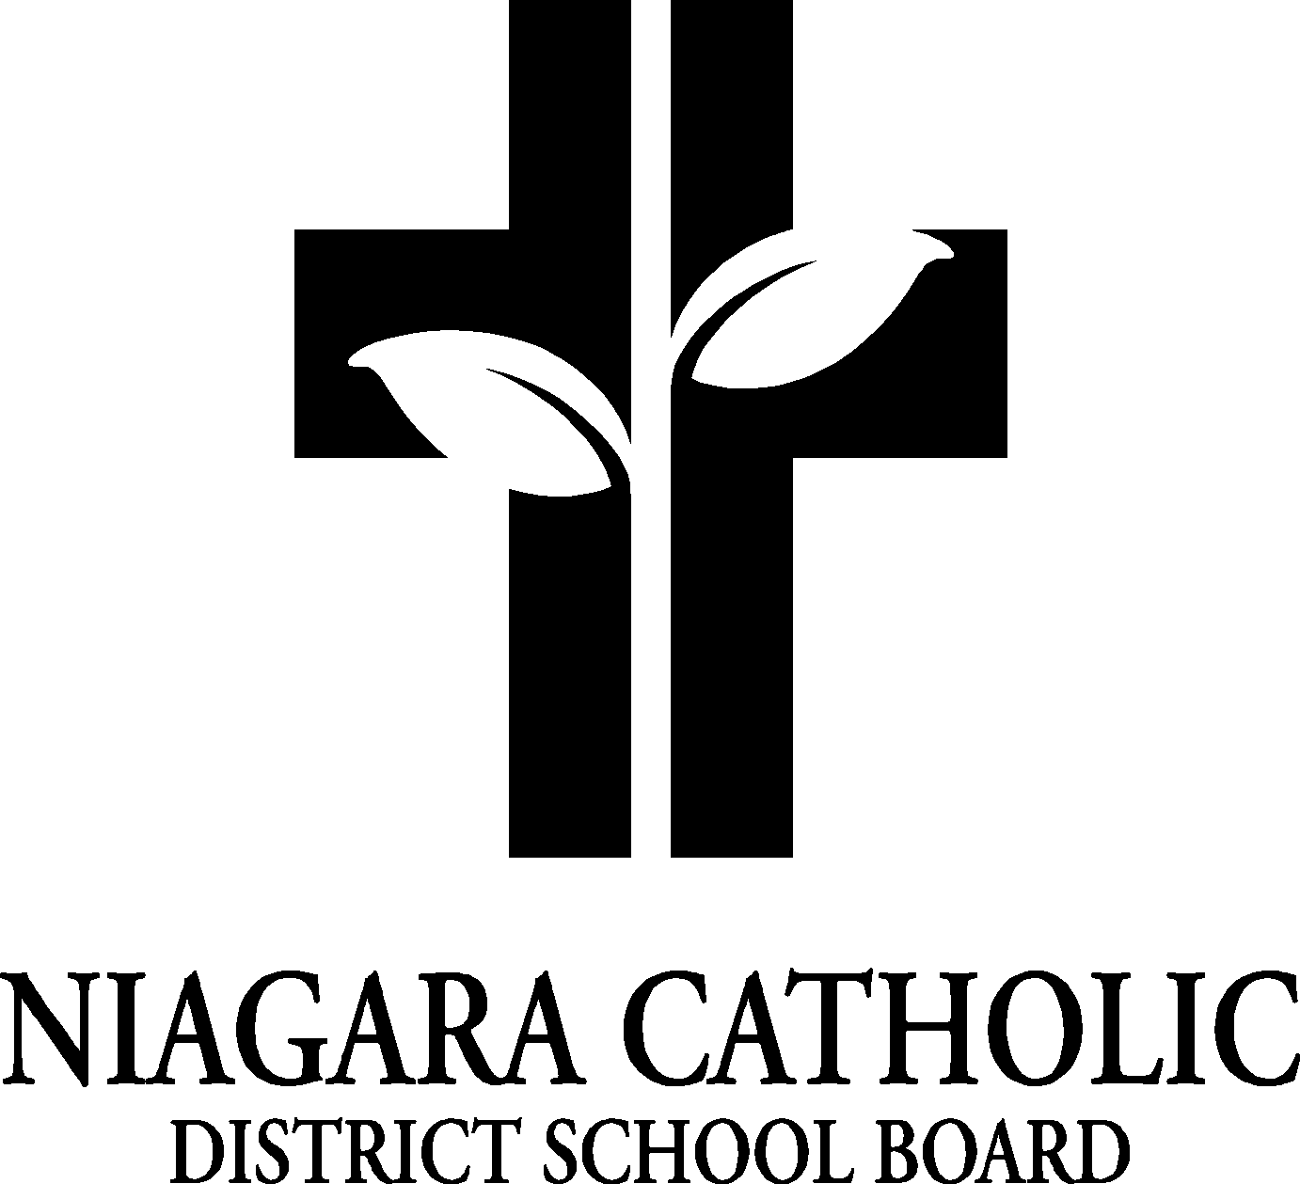

AGENDA
ST. PATRICK CATHOLIC
CATHOLIC SCHOOL COUNCIL MEETING

MONDAY, NOV. 29th, 2021
Virtual Google Meeting

- ROUTINE MATTERS
- Opening Prayer
- Roll Call
- Approval of Agenda
- Disclosure of Conflict of Interest
- Approval of the Meeting Minutes of the St. Patrick Catholic School Council Meeting of Sept. 27th, 2021

- PRESENTATIONS: n/a
- POLICIES FOR VETTING: Establishment and Cyclical Review of Policies Policy,
Supporting Children and Students with Prevalent Medical Conditions Policy,
Trustee Honorarium Policy : Feedback by Dec. 15, 2021

- PRINCIPAL’S REPORT
- Niagara Catholic Parent Involvement Committee Report (NCPIC)
- Special Education Advisory Committee (SEAC) Report

- OAPCE REPORT(Ont. Assoc. for Parents in Catholic Education): Trish

- STAFF REPORT: Mrs. Villegas and Mrs. Rombough

- AGENDA ITEMS-DISCUSSION FOR FUTURE MEETINGS

- NEXT MEETING: Feb. 28th, 2021 at 6 p.m.

- CLOSING PRAYER

- ADJOURNMENT

Principal’s Report

Catholicity:
- Remembrance Day Ceremony-Beautiful-Mr. Pascoe/Mr. Basilone
- Holy Childhood Walk: Mr. Curcio
- Prayer Services with Father Gerard and St. Mary’s School-monthly
- Chaplaincy Leader: Faith Mini Retreats (Dec. 15-17) Kinder-Grade 7
- Grade 8 Confirmation: April 30th
- First Communion and First Reconciliation: TBA
- Advent Begins: Prayers every Monday
- Blessing of the Wreaths: Nov. 29th
- Advent Confession: TBA
- Advent Mass: Nov. 29th at 11 am
- Christmas Food Drive Starts Dec. 1st
- Christmas “Hot Chocolate Day” -

Curriculum:
- Technology Update (20 new Chromebooks and COW)- ARRIVED
- Math Goals/School Improvement Planning-Math Mindset: Math UP, Knowledge Hook and Dream box
- Progress Reports on line
- Library: 800 dollars in new books
- Itinerant Arts Continues: Ms. Tham and Mr. Ciolfi
- EQAO: Virtual this year
- Staples: and Knights of Columbus-
- St. Paul: Transition Visits to begin (St. Paul Day Dec. 15)

Climate:

- COVID updates
- School Wide (Bully Awareness Week/Project Plaid)-CARSA/Teen Connect
- School Council Grade 7/8’s
- Food Days: Pizza and Pasta-feedback
- ECO club: will continue-Litter less Wednesdays/Natural Playground
- Natural Playground Ribbon Cutting -Thank you
- Breakfast Club update: Adriana
- Dental Screening (Kinder, Grade 2,4,7)
- Alternate Dress Days/Spirit Wear: Dec. 3rd: JOY DAY, Dec. 10th Jingle Bell Day-show off your Christmas bling
- Parent Communication-after Progress Reports.
- Next Fundraiser?
- Mom’s Pantry: Update and Pickup? Dec. 14th?
- Grade 8 Graduation: June 27th, 2022

