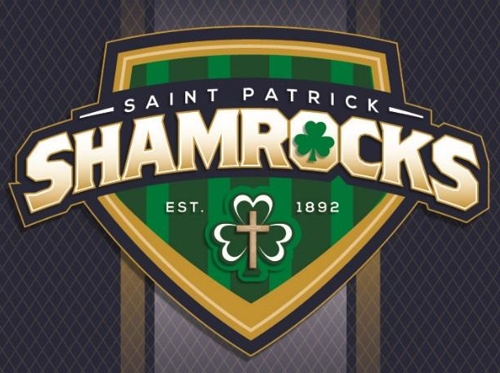
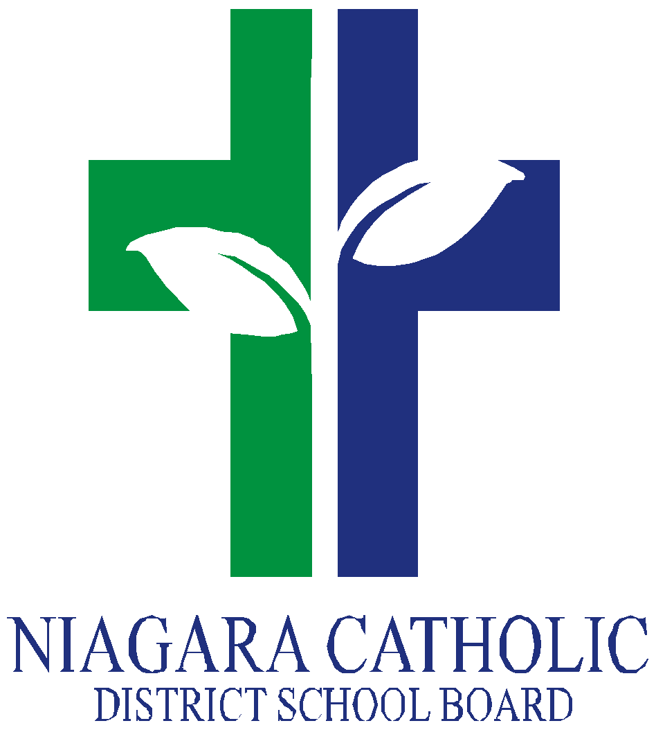
St. Patrick Catholic School

4653 Victoria Ave., Niagara Falls, ON
Tel: (905) 354-6631

CATHOLIC SCHOOL COUNCIL MEETING AGENDA
DATE: Monday, November 29, 2021

- ROUTINE MATTERS
1. Land Acknowledgement and Opening Prayer – Mrs. Ricci
2. Roll Call
Members | Affiliations | Present | Excused | Absent
Trish McGilvery | Co-Chair | √
Nancy Phillips | Co-Chair | √
Mrs. Ricci | Treasurer- Principal | √
Mrs. Villegas | Teacher Representative/Recording Secretary | √
Mrs. Rombough | Non-Teaching Representative | √
 | Parish Representative
 | Community Representative
Parent Representatives
Mrs. Phillips |  | √
Mrs. McGilvery |  | √
Mr. McGilvery |  | √
Ms. Gold |  | √
Mrs. Sawada |  | √
Ms. Ladd |  | √

3. Approval of the Agenda
4. Approval of the Minutes from September 27, 2021

- FAITH FORMATION

REPORTS FROM THE DIRECTOR’S MEETING
- Board Policy Vetting

- PRESENTATIONS – There are no presentations at the time.

- BUSINESS ARISING FROM THE MINUTES OF THE MEETING

- review of success of Mom’s Pantry fundraiser

- PRINCIPAL’S REPORT – Mrs. Ricci

- OAPCE Update (Mrs. McGilvery): online website with three avenues for parents to gather information: Mental Health, Student Achievement, Virtual Learning

- STAFF REPORTS:

Mrs. Rombough:

- Snack program supported by donations from St. Patrick Catholic Church~ rather than students gathering for the Breakfast Club at the church hall before school, church gives snacks to school.
- Community Crew also provides support with boxed lunches for families that need support.
- Food for Kids provides bags of groceries for students on a Friday to ensure children have nourishment over the weekend at home.

Mrs. Villegas:

- Vital to have families accessing NCVLE platform to build familiarity in case we need to pivot once again to online learning. NCVLE is different from GOOGLE Classroom.
- Ensure children have boots to wear to school as well as indoor shoes to be kept at school.
- Student absences MUST be entered into the SafeArrival system.
- SchoolCashOnline is the only accepted form of payment at St. Patrick.
- Please complete and adhere to daily COVID-19 screener.

- NEW BUSINESS/QUESTIONS

*Fundraising:

- Mom’s Pantry (Successful! December delivery)
- Pasta Night (February) ~ sub committee to meet in January 2022
- *Possible Valentine’s Day/Kids Helping Kids Week treat available for purchase*
- Raffles Baskets with each class responsible for preparing a themed basket (March)
- Big Red (May/June)

Virtual Mass to begin Advent Season and bless classroom Advent wreaths was held on Monday, November 29th, 2021 as hosted by St. Mary Catholic School. Next mass will be held in January hosted by St. Patrick (virtual or in person TBD)

St. Paul Catholic High School Day December 15, 2021 for St. Patrick Catholic School Grade 8’s “A Day at St. Paul”

“Litterless Lunch” Wednesdays starting this week with students eligible to earn raffle tickets with an eco-friendly lunch.

Dental Screening for students in Kindergarten, Grades 2, 4, 7 will be held at school on December 14, 2021. Parents must notify school if they do not want their child(ren) to participate.

Project Share Food Drive will be held December 1st-17th, 2021.

Mr. Pascoe’s class will be hosting a “Hot Chocolate Day” to raise funds to purchase Tim Horton gift cards for Fr. Gerrard to distribute to the needy in the community. Hot chocolate will be available for purchase through SchoolCashOnline.

“JOY DAY” will be held on Friday, December 3, 2021 as we prepare for the Christmas season as a school community.

“Jingle Bell Day” will be held on Friday, December 10, 2021~ wear your festive accessories.

Grade 8 Graduation will be held on June 27, 2021.

- NEXT MEETING – Monday, February 28, 2022

- ADJOURNMENT 7:13pm

