|  |  |
| --- | --- |
| Niagara Catholic District School Board  ***SEXUAL MISCONDUCT***  ADMINISTRATIVE OPERATIONAL PROCEDURES | |
| **200 – Human Resources** | **No 201.13** |
|  |  |
| Adopted Date: June 26, 2006 | Latest Reviewed/Revised Date: June 17, 2014 |

In keeping with the Mission, Vision, and Values of the Niagara Catholic District School Board, the following are Administrative Operational Procedures for Sexual Misconduct.

**PREAMBLE**

The Board believes that all students, employees, volunteers and other individuals who have a legal right to be at sites owned, leased, operated or being used by the Board, have a right to study and work in an environment free from sexual misconduct.

Students, employees, volunteers and other individuals who have a legal and educational right to be at sites owned, leased, operated or being used by the Board and who lodge a complaint of sexual misconduct, or who report their suspicion of such conduct, must be able to do so without threat or fear of reprisal. The complainant and the accused have equal rights at all steps throughout the process.

**DEFINITIONS OF SEXUAL MISCONDUCT**

*Definitions are subject to changes from time to time as the appropriate legislation is reviewed and amended.*

1. **Sexual Abuse**

Sexual abuse is a form of professional misconduct. The Student Protection Act defines sexual abuse of a student and amends the Ontario College of Teachers Act to include this definition:

* + sexual intercourse or other forms of physical sexual relations between the member and a student,
  + touching, of a sexual nature, of the student by the member, or
  + behaviour or remarks of a sexual nature by the member towards the student.

1. **Sexual Misconduct**

Sexual misconduct is inappropriate behaviour, remarks or conduct of a sexual nature in person or electronically where the employee knows or should know that the behaviour or remarks, may cause distress, be detrimental to the person’s physical or mental well-being, affect the personal integrity, or security of any student, employee of the Board, volunteers or other persons covered by this policy, as well as the creation of a negative school environment.

1. **Sexual Harassment**

Sexual harassment of students may be defined as a form of sexual misconduct as follows:

Inappropriate behaviour or remarks of a sexual nature which may constitute professional misconduct include, but are not limited to, conduct that would amount to sexual harassment or sexual discrimination under the Ontario Human Rights Code. These need not be overtly sexual but may nonetheless demean or cause personal embarrassment to a student, based upon a person’s gender, race or sexual orientation.

Board employees of the Niagara Catholic District School Board must avoid even a single event that may constitute sexual harassment, including but not limited to:

* objectionable conduct or comments incompatible with the role of an employee regardless of whether the affected student(s) appear to be offended by the conduct or comments
* sexual harassment of non-students or of co-workers
* reprisals or threatened reprisals for rejecting sexual advances.

1. **Sexual Relationships with Students**

Regardless of the age of a student and whether there are any criminal law considerations, it is unacceptable for Board employees of the Niagara Catholic District School Board to engage in or attempt to establish a sexual relationship with a student.

Sexual relationships include, but are not limited to, any sexual relationship with:

* a student, regardless of the student’s age
* a former student under the age of 18
* a former student who suffers from a disability affecting his or her ability to consent to a relationship.

Responsibility for ensuring that an employee student relationship is professional and appropriate rests with the employee and not with the student. This remains the case even when it is the student who attempts to initiate an inappropriate relationship. Any conduct directed to establishing such a relationship may constitute professional misconduct.

A student may be a student who is in the school or school system where the employee is employed, or in relation to whom an employee is otherwise considered to hold a position of trust and responsibility.

Board employees of the Niagara Catholic District School Board must not engage in activity directed to establishing a sexual relationship. This includes, but is not limited to:

* any form of sexual touching of students
* sending intimate correspondence to students
* making telephone calls of a personal nature to students
* engaging in sexualized dialogue through any means with students
* making suggestive comments to students
* dating students
* giving personal gifts to students
* grooming of students

Board employees of the Niagara Catholic District School Board **must avoid:**

* inviting individual students to their homes
* seeing students in private and isolated situations
* exchanging personal notes, comments or communication
* becoming personally involved in students’ affairs
* sharing personal information about themselves to students
* making physical contact of a sexual nature with a student

1. **Professional Misconduct for Staff**

A sexual relationship with a student or former student, or conduct directed to establishing such a relationship, may be regarded as professional misconduct. This conduct may also amount to sexual exploitation or sexual assault, which is addressed in the Criminal Code of Canada and the Ontario College of Teachers Act.

Where allegations of sexual misconduct are consistent with those offences outlined in the Criminal Code, the procedures set out through the FACS and Niagara Regional Police Protocols must be followed.

Where sexual misconduct may not amount to a criminal offence, but may amount to professional misconduct, then the Principal of the school and/or the Immediate Supervisor must conduct an investigation of the matter.

The matter of the investigation shall be conducted in a fair and judicious manner to ensure the confidentiality of all parties. The alleged perpetrator will be entitled to representation during questioning. Allegations about sexual misconduct usually require an explanation.

1. **Criminal Offences**

The following offences are considered Criminal in nature under the Criminal Code of Canada.

* Sexual interference - is an offence, which victimizes children under age 14. Generally, sexual interference involves an adult touching a child for a sexual purpose.

Invitation to touching - is also an offence as it applies to children under the age of 14. Generally, this act involves an adult inducing a child to touch him or her. It is not a defense that the child purportedly consented to such activity.

* Sexual exploitation - conduct of a sexual nature that is committed by a person who is in a position of trust or authority towards a young person (meaning a person at least 14 years old but under 18 years of age).
  + It is not a defense that the young person purportedly consented to the activity. Teachers and other school personnel and volunteers will almost inevitably be regarded as being in positions of trust or authority respecting students with whom they interrelate.
  + Indecent act and sexual exposure - criminalize indecent acts or the exposure of private parts, even absent of any suggested or actual physical contact between the perpetrator and another person. Sexual Assault - is an assault committed in circumstances of a sexual nature such as to violate the sexual integrity of its victim.

**INVESTIGATION PROCEDURES**

All reports of sexual misconduct will be thoroughly investigated by the supervising administrator with a report to their immediate supervisor.

**Academic Teaching Staff**

The Student Protection Act also amended the Teaching Profession Act. A teacher who makes an adverse report about another member respecting suspected sexual abuse of a student by that other member need not provide him or her with a copy of the report or with any information about the report. “*Members of the College may not engage in, or threaten to engage in, reprisals against anyone who discloses, reports for otherwise provides information with respect to alleged or suspected professional misconduct of a sexual nature.”*

Nor shall any disclosure be made that would undermine any ongoing or contemplated police or Family and Children’s Services (FACS) investigation.

The receiver of the complaint will treat the complaint and those associated with sensitivity and afford all the necessary protection in handling of such complaints.

Confidentiality will be respected and maintained at all times as required by relevant legislation.

Anyone who retaliates or threatens to retaliate against a person, who makes a complaint or reports alleged misconduct, in good faith, shall be subject to disciplinary action up to and including termination of employment.

A teacher who makes an adverse report about another teacher suspected of physical or sexual abuse or harassment of a student by that other teacher, shall not provide him or her a copy of the report or with any information about the report.

Where applicable, and if permitted by law, Police or FACS as well the investigators of the Ontario College of Teachers should be consulted by the Board as to the nature and timing of disclosure of pertinent information to the alleged perpetrator.

Individuals who knowingly make unfounded allegations of sexual misconduct shall be subject to disciplinary action.

The Superintendent of Human Resources Services, under the direction of the Director of Education will ensure that:

* improper conduct is the subject of appropriate disciplinary action
* appropriate records of improper conduct are kept;
* prospective employers as well as professional bodies and organizations are properly notified of such conduct.

Sexual misconduct with students under the age of sixteen (16), the Protocols and procedures set out in the *Family and Children’s Services Niagara (FACS) Protocol* and the *Police and School Board Protocol* will be followed for alleged sexual misconduct.

**Board Employee**

Where a Board employee or volunteer is suspected of sexual misconduct, the individual making a report to FACS or the Police, shall notify the Principal and the appropriate Superintendent of Education who supervises the alleged perpetrator of the report.

**Principal**

Where the Principal is suspected of such conduct, the notification of the report shall go to the appropriate Family of Schools Superintendent and to the Superintendent of Human Resources Services and/or the Director of Education.

**Superintendent of Education**

When a complaint is filed against the conduct of a Superintendent of Education, Superintendent of Business and Finance Services or the Controller of Facilities Services, the Director of Education will investigate the complaint.

An appeal of the decision by the Director of Education rests with the Board.

**Director of Education**

When a complaint is filed against the conduct of the Director of Education, the Director or the Chair of the Board, whoever receives the complaint will notify the appropriate Board Legal Counsel to determine the next course of action. A report will be presented to the Board at the earliest opportunity.

The Board liaison with the Niagara Regional Police will request from the Police that when they become aware that a Principal is under investigation for sexual misconduct that they notify the Superintendent of Human Resources Services.

**Reporting of an Allegation**

A student, employee or volunteer who has made a report concerning any allegation of sexual misconduct against an employee or volunteer and is not satisfied with the response may contact the Principal or the Family of Schools Superintendent directly to investigate the matter and to report back to the student, employee or volunteer the status of the investigation.

The subject matter of the complaint should not be discussed with the alleged perpetrator until specific instructions are received from the investigating Police or FACS personnel conducting the investigation.

Senior Administration is obliged to address the interim status of the employee or volunteer against whom allegations of sexual abuse have been made, pending a preliminary investigation of the allegation.

When considering the interim status of an individual accused of misconduct, safety and security of the alleged victim (s) is paramount. However, the interim status must also reflect a consistency of approach following the principles of procedural fairness to all affected.

Where sexual abuse has been alleged against an employee or a volunteer, the subject of the allegations should be removed from the classroom or from situations involving unsupervised access to students, pending determination as to whether abuse has occurred.

Depending on the circumstances, removal may involve reassignment to other duties, suspension or in some circumstances, commencement of termination proceedings.

While the Family and Children Services/Police determination may be an "unable to verify report", the Board may still, in its discretion, determine that there is sufficient information from its own investigation for discipline or discharge.

An employee or volunteer’s assignment, re-assignment or employment status should be revisited upon completion of any police or FACS investigation, after any criminal charges are laid, after any criminal case is completed and upon completion of any internal investigation.

Where sexual misconduct is alleged, the police, together with FACS, if the allegations fall within the FACS jurisdiction, will conduct the investigation.

Any internal investigation should be deferred, pending conclusion of any ongoing or contemplated police investigation.

**Where the Alleged Victim is Sixteen (16) and Over**

* Where an employee or volunteer of the Board has reasonable grounds to suspect that a student sixteen (16) and over has suffered, or is at risk of likely suffering, sexual abuse as a result of actions of a person having charge of that student, they shall forthwith report those suspicions and the information on which they are based directly to the police.
* Such employees or volunteers shall also notify the Principal of the school who supervises the alleged perpetrator of the report. If the Principal is the suspected perpetrator, the employee or volunteer shall notify the appropriate Superintendent of Education of this report.
* Given the age of the complainant/ student, after a report has been made to the police, the parents should not be notified of the complaint or allegations unless specific consent has been obtained from the student.
* If the alleged perpetrator has access to children under the age of 16, the statutory reporting obligation of notifying FACS will also be triggered regardless of the fact that the particular student suspected to have been abused is 16 years of age or over.

**Where the Alleged Perpetrator is a Student**

* In some cases, a young offender (after they attain the age of 12) may be criminally responsible for sexual abuse.
* Where a student is alleged to have sexually abused another student the procedures outlined in the FACS protocol and Niagara Regional Police protocol must be followed.
* The Principal, in consultation with the Superintendent of Education, will review the available information to determine whether the student who is alleged to have abused another student may remain in school pending investigation of the matter.
* Where the student is charged with the sexual abuse of another student, the Principal, after consultation with the Police and FACS, will immediately remove the alleged offender from the school until the investigation is completed or the charge has been disposed of or a decision is made by the Superintendent of Education.
* Upon conclusion of the matter, the Principal in consultation with the Superintendent will determine the placement of the student.

**Employer Responsibilities**

1. The Student Protection Act stipulates that employers must report to the Ontario College of Teachers at the time member is charged with a sexual offence.

The Director of Education shall promptly notify the Ontario College of Teachers in writing when they have dismissed, suspended or otherwise disciplined a member who is employed by the Board for an action of professional misconduct, and provide the reasons for such action.

The Director of Education shall promptly notify the Ontario College of Teachers in writing where, in the opinion of the Director, a committee of the Ontario College of Teachers should review the conduct or actions of a member who is or has been employed by the Board.

Where a current or former employee is not a member of the Ontario College of Teachers, the Director of Education shall promptly notify any applicable licensing body in writing of the circumstances set out above.

The removal of the teacher or individual from the classroom may be considered as an interim measure until the investigation is complete.

The matter once investigated and found to have merit, will require disciplinary action up to and including termination of employment.

**Appendix A** Sexual Misconduct Complaint Form

***References***

* ***[Child and Family Services Act](http://www.e-laws.gov.on.ca/html/statutes/english/elaws_statutes_90c11_e.htm" \t "_blank)***
* ***[Criminal Code of Canada](http://laws.justice.gc.ca/en/C-46/" \t "_blank)***
* ***[Education Act](http://www.e-laws.gov.on.ca/html/statutes/english/elaws_statutes_90e02_e.htm" \t "_blank)***
* ***Ontario*** [***Human Rights Code***](http://www.ontario.ca/laws/statute/90h19)
* [***Ontario College of Teachers Act***](http://www.ontario.ca/laws/statute/96o12)
* ***Ontario College of Teachers*** 
  + ***Professional Misconduct of a Sexual Nature, September 22,2019***
  + [***The Ethical Standards for the Teaching Profession***](http://www.oct.ca/public/professional-standards/ethical-standards)
  + [***The Standards of Practice for the Teaching Profession***](http://www.oct.ca/public/professional-standards/standards-of-practice)
* ***Ontario Regulations***
* [***Ontario Regulation 298 - Operation of Schools - General***](http://www.ontario.ca/laws/regulation/900298)
* [***Ontario Regulation 437 / 97 - Professional Misconduct***](http://www.ontario.ca/laws/regulation/970437)
* [***Ontario Regulation 521 / 01 - Collection of Personal Information***](http://www.ontario.ca/laws/regulation/010521)
* [***Robins Report***](http://www.attorneygeneral.jus.gov.on.ca/english/about/pubs/robins/)
* ***[Safe Schools Act, 2000](http://www.e-laws.gov.on.ca/html/source/statutes/english/2000/elaws_src_s00012_e.htm" \t "_blank)***
* ***[Student Protection Act, 2002](http://www.e-laws.gov.on.ca/html/source/statutes/english/2002/elaws_src_s02007_e.htm" \t "_blank)***
* [***Teacher Profession Act***](http://www.e-laws.gov.on.ca/html/statutes/english/elaws_statutes_90t02_e.htm)
* ***Niagara Catholic District School Board Policies/Procedures***
* ***[Bullying Prevention & Intervention Policy (302.6.8)](https://docushare.ncdsb.com/dsweb/Get/Document-1982053/302.6.8%20-%20Bullying%20Prevention%20%20&%20Intervention%20Policy.pdf)***
* ***[Employee Workplace Harassment Policy (201.7)](https://docushare.ncdsb.com/dsweb/Get/Document-1982038/201.7%20-%20Employee%20Workplace%20Harassment%20Policy.pdf)***
* ***Family and Children’s Services Niagara (FACS) Protocol***
  + ***Police Protocol between the Niagara Regional Police Services and the Niagara Catholic District School Board***
  + [***Privacy Policy (600.6)***](https://docushare.ncdsb.com/dsweb/Get/Document-1982062/600.6%20-%20Privacy%20Policy.pdf)
  + ***Privacy Breach Protocol***

|  |  |
| --- | --- |
| **Adopted Date:**  **Revision History:** | **June 26, 2006**  **June 17, 2014** |

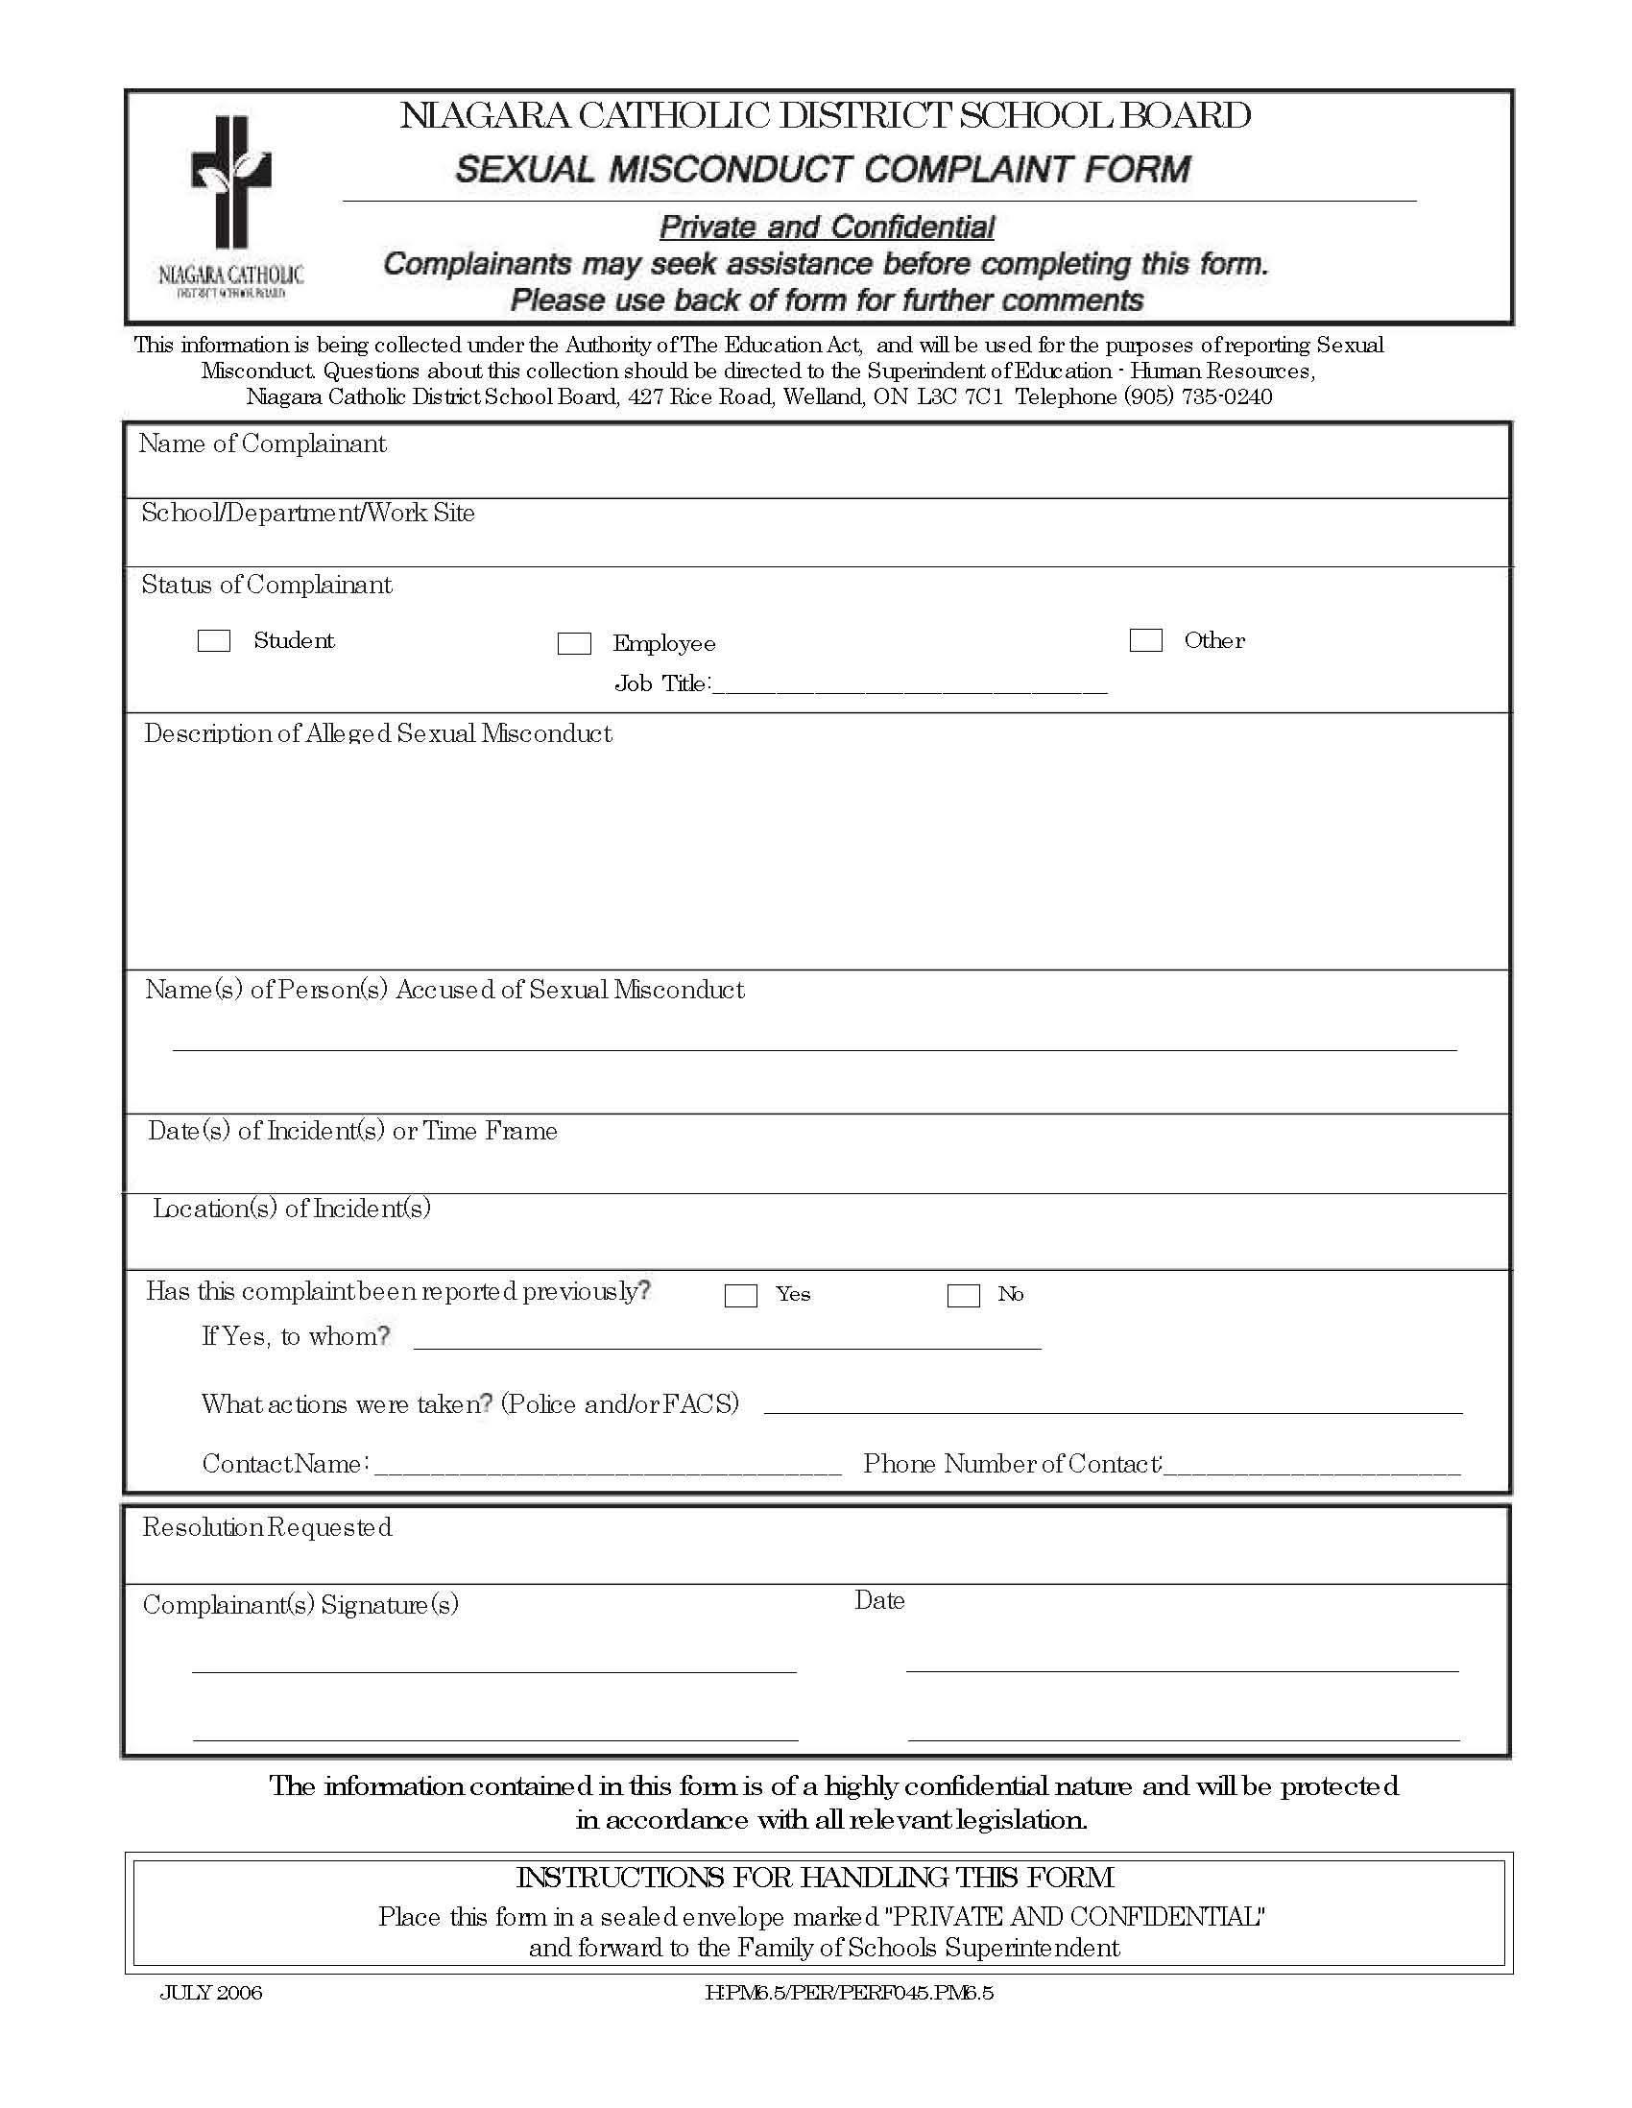

**APPENDIX A**