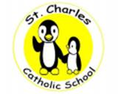Description: Niagara Catholic

St. Charles Catholic School

25 Whyte Avenue, Thorold, Ontario, L2V 2T4 Tel: (905) 227-3522

Principal: C. Zanuttini Secretary: K. Twardawsky

Parents/ Guardians,

Please ensure the school has the most up to date information email addresses and phone numbers for your family so we can continue to send you calendars and important information.

To make any changes, please call the school at 905-227-3522 or send a note with the information in with your student.

Thank you

*“The Niagara Catholic District School Board, through the charisms of faith, social justice, support and leadership, nurtures an*

*enriching Catholic learning community for all to reach their full potential and become living witnesses of Christ.”*