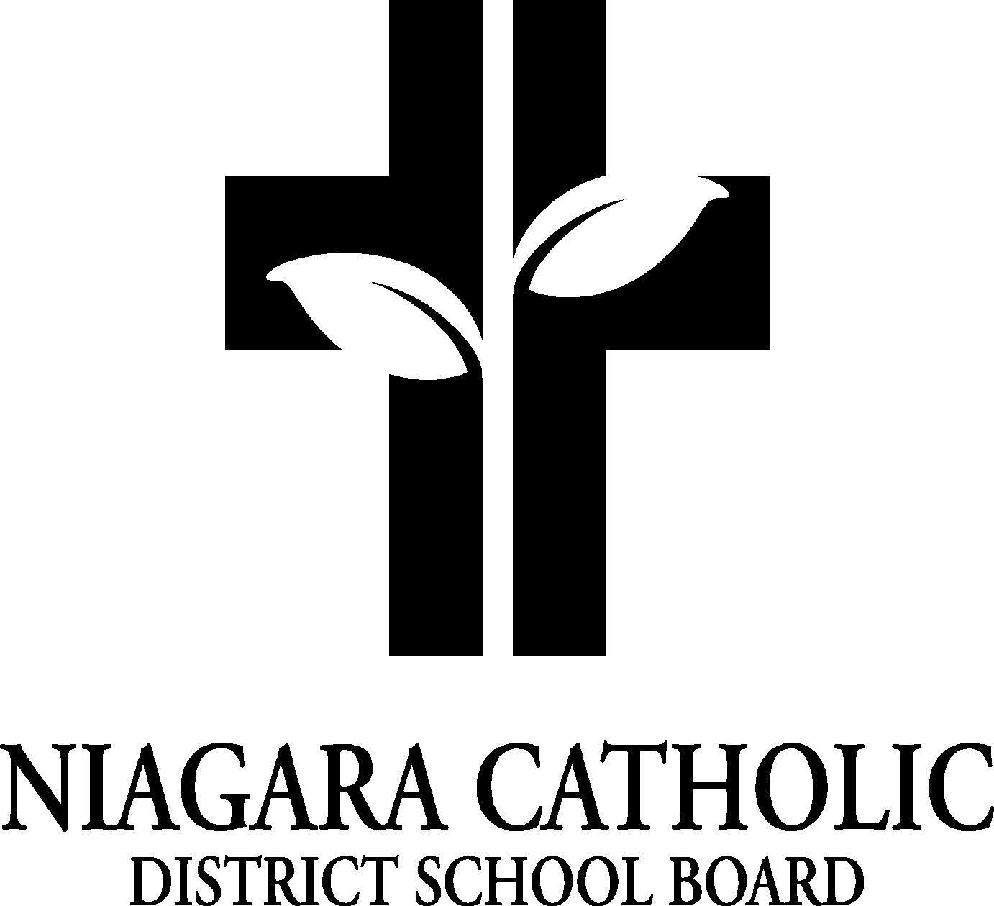

AGENDA
ST. JOSEPH CATHOLIC SCHOOL COUNCIL

MONDAY NOVEMBER 30/2015
LIBRARY

A. ROUTINE MATTERS

1. Opening Prayer
2. Roll Call
3. Approval of the Agenda
4. Disclosure of Interest
5. Approval of Minutes of the St. Joseph Catholic School Council Meeting of October 20/15

B. PRESENTATIONS
Staff-Mr. Vukovic
Bingo-Kelly DiLapo
Nutrition-Sandy Skingley, Karen Martens
Garden/ECO-Sandy Skingley
Bingo/Nevadaman secretary-Maria/Brenda
C. PRINCIPAL’S REPORT

- Niagara Catholic Parent Involvement Committee (NCPIC) Report
- Special Education Advisory Committee (SEAC) Report
- Catholic School Council Financial Report
- Silent Auction Gift baskets
- Christmas Parades in area
- Fundraising (Grade 7/8), Camp Medeba, Sub-committe
- Cash Net-Milk Program, Pita Pit
- Secretary at St. Joseph
- Sacraments/Mass
- Maddalena Orders/Grad Hoodies
- Mary Poppins
- Progress Report Card Parent-Teacher Interviews
- Thanksgiving Luncheon-Thank you notes
- Policy Vetting
- Skating
- Dental Screening
- Advent Prayer Services, Advent Mass with the Bishop
- Christmas Extravaganza
- Food Drive for St. Vincent de Paul
- New Absence Reporting for parents/on-line attendance for teachers
- ELKP Open House-January 13 (registration all month), Lakeshore Catholic and St. Michael Open House

D. OAPCE REPORT-Karen Martens (probably no report)

E. STAFF REPORT

F. AGENDA ITEMS-DISCUSSION FOR FUTURE MEETINGS

G. NEXT MEETING

H. ADJOURNMENT

I. CLOSING PRAYER

