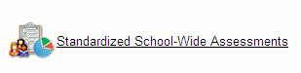
USER GUIDE
Through Maplewood connectEd, staff can record and view various assessment data, including:
- Grade 3, 6 and 9 EQAO Assessments
- PM Benchmark (K to 3)
- Developmental Reading Assessment (DRA) (Grades 4 to 8)
- Ontario Comprehension Assessment (OCA) (Grades 7 to 10)
The Standardized School-Wide Assessments in Maplewood connectEd includes the following benefits:
- Safe storage of student assessment data
- Easy to record current student assessment data
- Easy to view past student assessment data
- Information entered can be viewed by receiving staff which can support student transitions from grade to grade and from elementary to secondary school
- Information entered supports teachers in their work to understand the baseline level of achievement of their students in support of next steps in instruction and assessment
To access the Standardized School-Wide Assessments, log into Maplewood connectEd at http://mw.ncdsb.com/, select the school and login with your Maplewood credentials used for reporting.
From the Menu, select Standardized School-Wide Assessments:
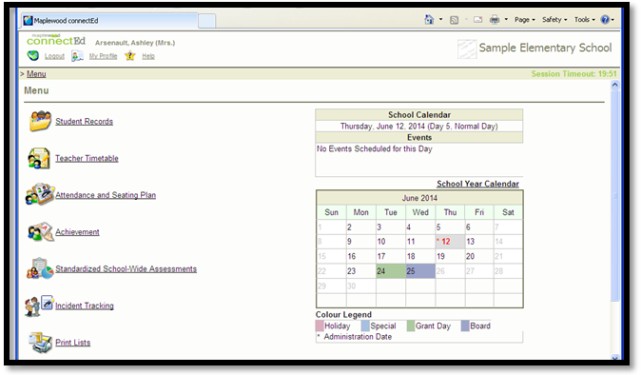

In Standardized School-Wide Assessments, choices about the class to view are available under Filter By. Under Select Assessment By, choose the Assessment Name to view or enter student assessment data.
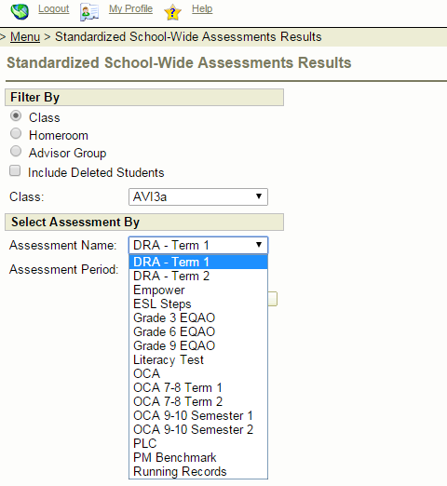
To enter PM Benchmark data, there is a dropdown for the PM Benchmark level for 0 to 30.
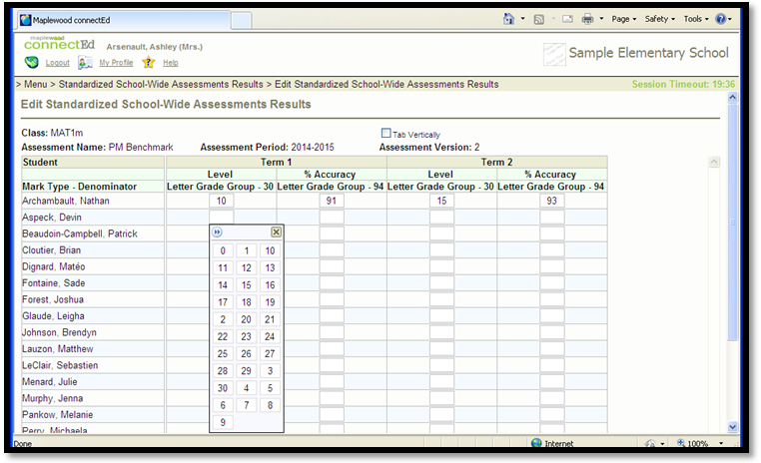

For PM Benchmark data, the % Accuracy column allows the user to enter a percentage of 90 to 94. This should ensure that the Level entered is the instructional level of reading for the student.
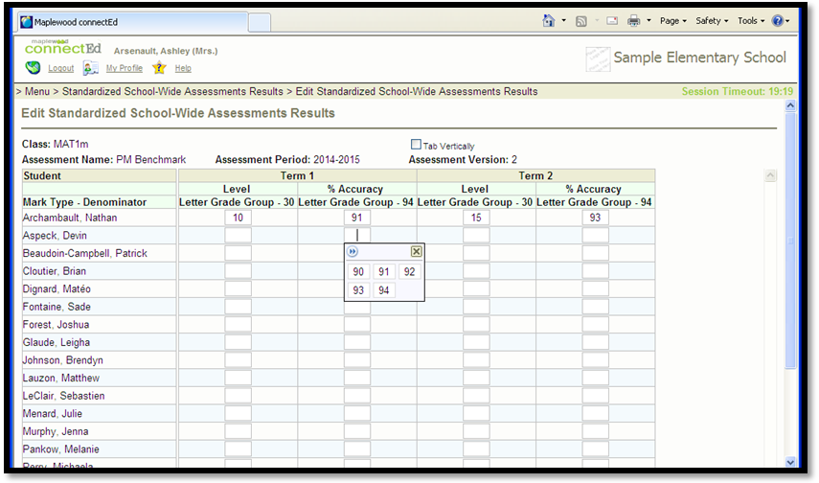
Click on the Save button at the bottom of the student list to save any data entered or changed. Click on the Save & Go Back button to save any data entered or changed and return to the Standardized School-Wide Assessments Results page.
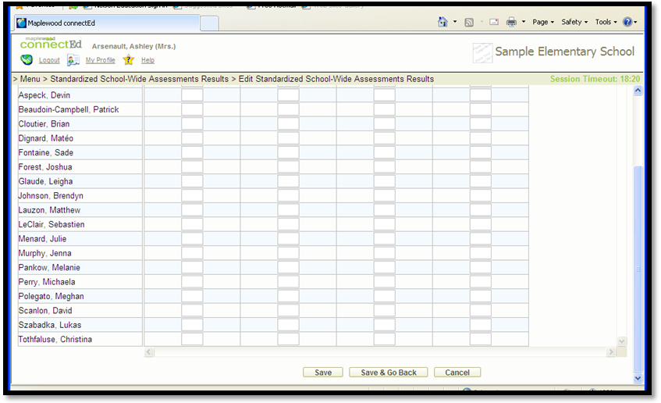

To enter DRA data, select the appropriate Term – Term 1 or Term 2. For each column, a dropdown menu shows the Level selections – 1 to 4.
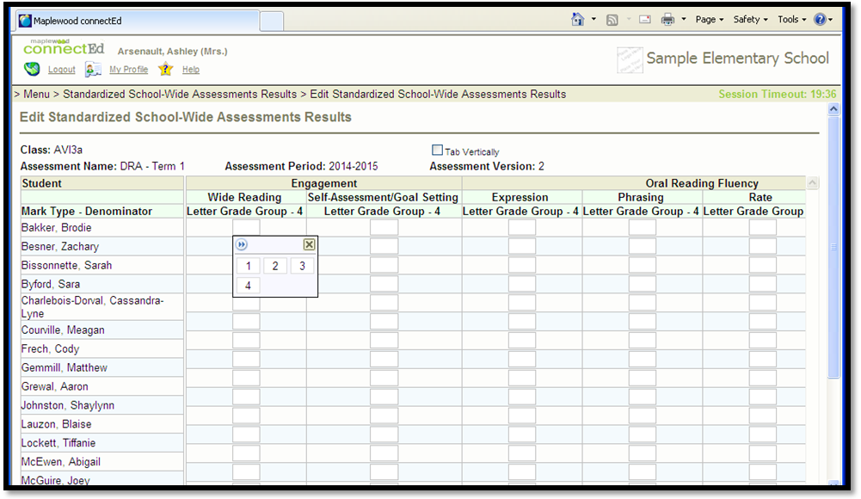
For DRA data, the Text Level Used includes the selection of Levels 40, 50, 60, 70 and 80.
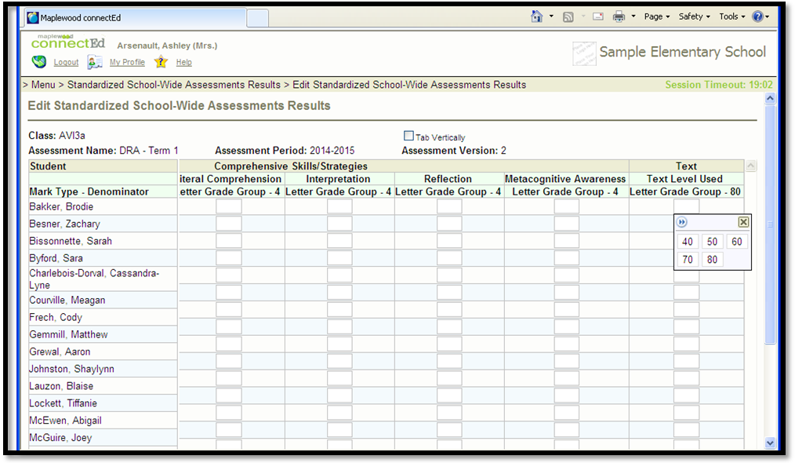

To enter OCA data for Grades 7 and 8, select the appropriate Term – Term 1 or Term 2. For each column, a dropdown menu appears. For Text, the Early (E) and Late (L) levels are available for 4 to 8. Please be reminded that the OCA Success Kit contains readings starting at Grade 4 level, to support understanding students’ reading levels for those not currently reading at grade level.
Generally, 7E and 8E text selections would be used in Term 1 and 7L and 8L text selections would be used in Term 2 for students reading at or near grade level.
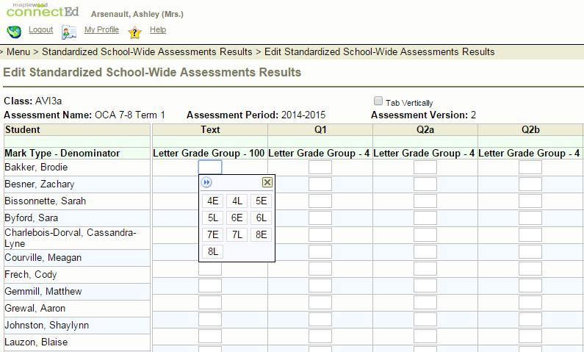
To enter OCA data for Grades 7 and 8, a dropdown menu is available that includes Levels 1- to 4+.
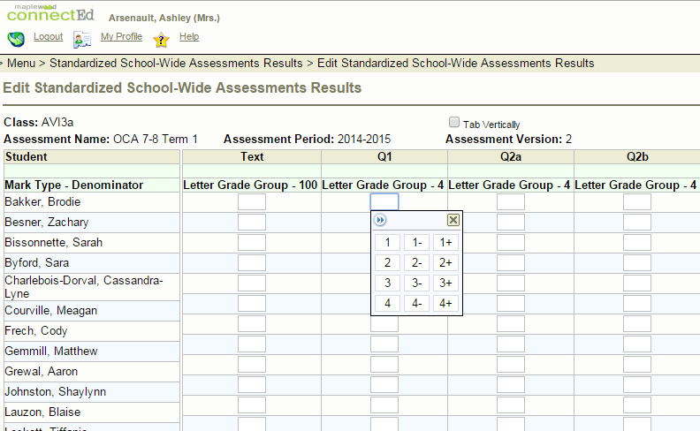
To enter OCA data for Grades 9 and 10, select the appropriate Semester – Semester 1 or Semester 2. For each column, a dropdown menu appears. For Text, the Early (E) and Late (L) levels are available for 4 to 10. Please be reminded that the OCA Success Kit contains readings starting at Grade 4 level, to support understanding students’ reading levels for those not currently reading at grade level.
Generally, 9E and 10E text selections would be used in Semester 1 and 9L and 10L text selections would be used in Semester 2 for students reading at or near grade level.
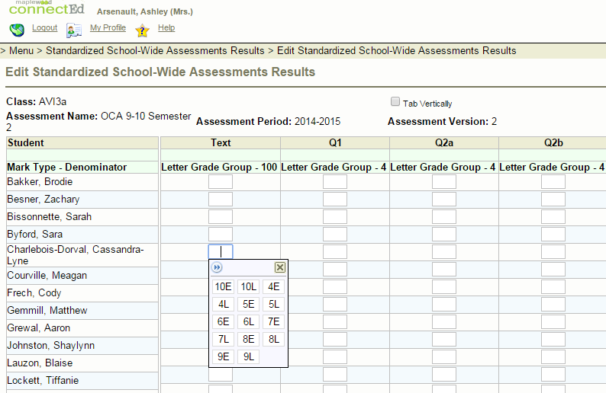
To enter OCA data for Grades 9 and 10, a dropdown menu is available that includes Levels 1- to 4+.
