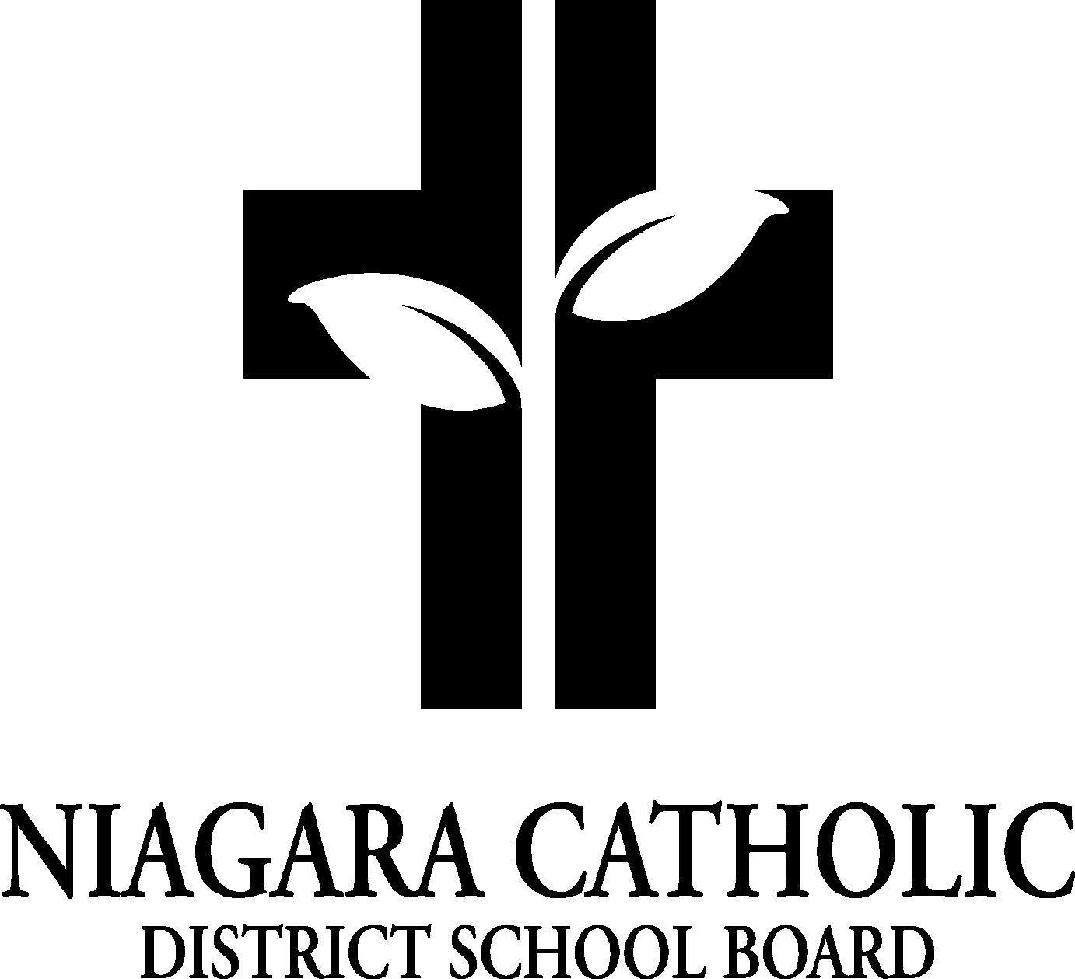

AGENDA
St. Mary CATHOLIC SCHOOL Niagara Falls COUNCIL MEETING

DATE: September 15, 2025
Location: St. Mary Catholic Elementary School Niagara Falls Library

A. ROUTINE MATTERS

- Opening Prayer
- Roll Call
- Approval of the Agenda
- Election of Chair and/or Co-Chairs (when necessary)
- Election of the Ontario Association for Parents in Catholic Education (OAPCE)-
(when applicable)
- Disclosure of Interest
- Approval of Minutes of the St. Mary Catholic School Council Meeting of September 15, 2025 – first meeting of the school year. This will be deferred until next Catholic School Council Meeting

B. PRESENTATIONS: n/a

C. PRINCIPAL’S REPORT
- Niagara Catholic Parent Involvement Committee (NCPIC) Report
- Ontario Association of Parents in Catholic Education (OAPCE) Conference – please see link if you’re interested in attending https://oapce.org/events/
- Can apply for funding for you to attend the conference
- Special Education Advisory Committee (SEAC) Report – nothing to report at this time
- Catholic School Council Financial Report – nothing to report at this time
- Fundraisers –
-Nutrition Program
- Technology in Classrooms
-Delta Bingo – need two volunteers for November /25
- Food Days and Milk – reflect Healthy Schools Initiatives
- Meet & Greet – Tuesday September 23 4:30-6:00 pm
- Linda McQueen Acknowledgement of Retirement – Tuesday September 23 @ Meet & Greet
Parent Engagement Funds – Focus for this year? -
Parent Involvement Memo 082 (2025-2026) Attachment-Parent Engagement Funding Application 2025-2026-Fillable.pdf
- Christmas Night – Gingerbread Houses?

D. POLICY REVIEW AND FEEDBACK
- Board By-Laws Policy (100.1) and the Trustee Electronic Meetings (Board and Committees) Policy (100.8) that are currently being vetted for your review and the NCPIC Policy Feedback
- Feedback to be submitted on behalf of the NCPIC is to be sent to Yvonne Anderson at yvonne.anderson@ncdsb.com no later than 12:00p.m. on Tuesday, October 28, 2025.
- Feedback being submit as an individual, is to be sent directly to Anna Pisano at anna.pisano@ncdsb.com no later than 12:00p.m. on Wednesday, October 29, 2025.

E. STAFF REPORT
- See Jennifer Alaimo’s Report Below

F. AGENDA ITEMS-DISCUSSION FOR FUTURE MEETINGS

G. NEXT MEETING

H. ADJOURNMENT

I. CLOSING PRAYER

