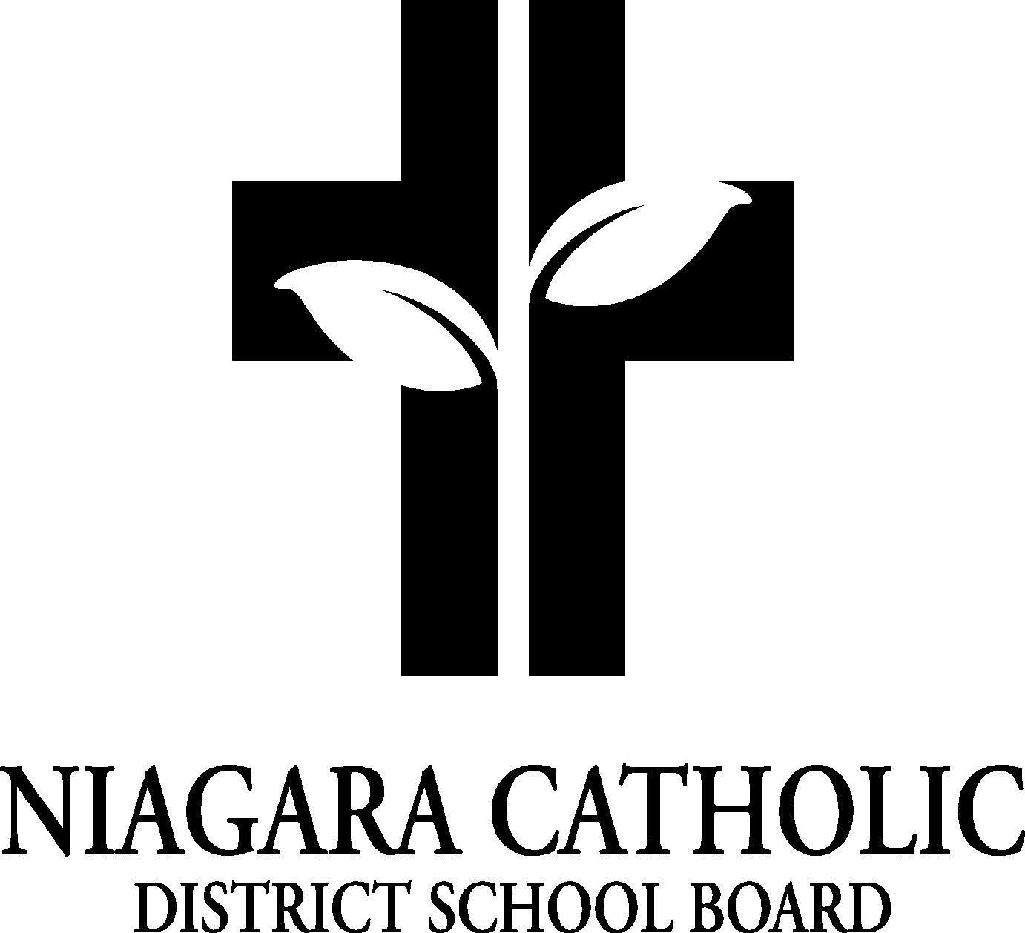

MINUTES OF THE
St. Mary CATHOLIC SCHOOL COUNCIL MEETING

DATE: September 15, 2025
Location: St. Mary Catholic Elementary School Library

Minutes of the Meeting of the St. Mary Catholic School Council, held on September 15, 2025 at 6:00 pm.

The meeting was called to order at 6:00 pm by Chair Derrick Copeland.

A. ROUTINE MATTERS

1. Opening Prayer

The opening prayer was led by Mrs. Solomon

2. Roll Call

CATHOLIC SCHOOL COUNCIL MEMBERSHIP |  | Present | Excused | Absent
Principal/Vice-Principal  Secretary/Treasurer | Maria Solomon – maria.solomon@ncdsb.com
Chair | Derick Copeland - dcopeland3@cogeco.ca
Co-Chair(s)
Teacher Representative | Jennifer Alaimo jennifer.alaimo@ncdsb.com  Erin Peskett erin.peskett@ncdsb.com
Non-Teaching Representative | n/a
Student Representative | n/a
Parish Representative | n/a
OAPCE Representative | n/a
PARENT/GUARDIAN MEMBERS
Katherine Lynett – katherinelynett123@gmail.com

Meaghan Misiak- meaghan.tudhope@gmail.com

Yirah Corona yirah.maria.corona@gmail.com

Stephanie Hancock - steph8han@gmail.com

3. Approval of the Agenda

Moved by Katherine Lynette
THAT the St. Mary Catholic School Council approve the Agenda of the St. Mary Catholic School Council Meeting of September 15, 2025.
CARRIED

4. Disclosure of Interest

No Disclosures of Interest were declared with any items on the agenda.
(If conflict of Interest is declared please record)

5. Approval of Minutes of St. Mary Catholic School Council Meeting of September 15, 2025

Moved by ___________________________
THAT St. Mary Catholic School Council approve the Minutes of the St. Mary Catholic School Council Meeting.
CARRIED

Congratulations to Derick Copeland who has been acclaimed as this year’s Catholic School Council Chair

- PRESENTATIONS: n/a

- PRINCIPAL’S REPORT

- Niagara Catholic Parent Involvement Committee (NCPIC) Report – none to report
- Special Education Advisory Committee (SEAC) Report – none to report
- Catholic School Council Financial Statement – nothing to report at this time.
- Niagara Catholic Parent Involvement Committee (NCPIC) Report
- Ontario Association of Parents in Catholic Education (OAPCE) Conference – please see link if you’re interested in attending https://oapce.org/events/
- Can apply for funding for you to attend the conference

Fundraisers:
-Nutrition Program – continue with Poinsettias at Christmas and providing an option to make a school donation through school cash online for the Nutrition Program
- Technology in Classrooms- M. Solomon shared that we will be purchasing a few more chromebooks from CSC’s fundraisings; currently have purchased 2 Smart TVs and 1 TV to replace outdated technology in the classroom along with 10 new Chromebooks
-Delta Bingo – Thank you to Katherine Lynette for volunteering for Delta Bingo November volunteers for November 22 /25 (12:00 noon -2:00pm)
-Gift Baskets – Spring during May (Catholic Education Week)
-Gift Card Calendar – During Valentine’s Day – M. Solomon will contact other colleagues to find out more information

Food Days and Milk – reflect Healthy Schools Initiatives
- M. Solomon to contact McNab for milk
- D. Copeland will begin on Tuesdays or Wednesdays Smoothie Days with fresh fruit.(Funds will come out of Nutrition Fund). Will begin in November. M. Solomon is to communicate with parents through School Messenger
- M. Solomon to contact Pita Pit & Subway
- D. Copeland to contact Swiss Chalet to see if they can substitute French Fries for a Healthy alternative
- Y. Corona will look into Kelly Greens Healthy Snack Ideas
- K. Lynett will look into Small Scale Farms and Odd Box
- Meet & Greet – Tuesday September 23 4:30-6:00 pm – same format as last year; will be gently worn dress code items, invite of SWISS workers and Niagara Falls Library
- Linda McQueen Acknowledgement of Retirement – Tuesday September 23 @ Meet & Greet
Cake will be offered. M. Solomon sent email with the minutes of tonight’s meeting to members of CSC asking for one of the members to look into getting coffee that evening. E. Peskett purchasing cake from Cosco. D. Copeland will be looking into the cutlery, paper plates and napkins.
-M. Solomon shared that Oct. 1/25 2-5 will be an Honorary Tea for Linda. Catholic School Council will help with the event.

Parent Engagement Funds – Focus for this year? – Healthy Schools
- M. Solomon to reach out to Josh Green from Go Fitness Niagara to see if he is interested in doing a parent engagement event and also working with students
Parent Involvement Memo 082 (2025-2026) Attachment-Parent Engagement Funding Application 2025-2026-Fillable.pdf
- Christmas Night – Making Gingerbread Houses - Wednesday, December 17, 2025
- Committee will advise when Cosco is selling the product and to purchase 55
- D. Copeland will pick up Gingerbread Houses

D. POLICY REVIEW AND FEEDBACK
- Board By-Laws Policy (100.1) and the Trustee Electronic Meetings (Board and Committees) Policy (100.8) that are currently being vetted for your review and the NCPIC Policy Feedback
- Feedback to be submitted on behalf of the NCPIC is to be sent to Yvonne Anderson at yvonne.anderson@ncdsb.com no later than 12:00p.m. on Tuesday, October 28, 2025.
- Feedback being submit as an individual, is to be sent directly to Anna Pisano at anna.pisano@ncdsb.com no later than 12:00p.m. on Wednesday, October 29, 2025.

E. STAFF REPORT
Staff Report for Catholic School Council
September 15, 2025 - Report Prepared by: J. Alaimo

- Month of September we have had our first fire drill on Sept. 10 and our first of two lockdown drills will be on September 18, 2025 (approx. 4 min. in length)
- Mrs. Solomon attended a St. Paul Gr. 8 Transition Mtg. with all the elementary schools in the
- St. Paul Family of Schools to discuss transition activities for our Grade 8 students
- Gr. 8s attended their Journeys Retreat in Stevensville today
- Sept. 19 is a PA Day for students; teachers will be attending a Faith Day that will begin at St. Patrick Church for mass followed by engaging in Bishop Bergie’s address and faith activities in the afternoon
- September 23 is our first school mass at 9:30ish for grade 1-8 along with our Meet the Teacher Night 4:30-6:00 pm
- September 24 (Junior Girls Soccer @ Michelson)
- September 25 (Junior Boys Soccer @ Michelson)
- Delta Bingo volunteers for this month is Ms. Brant and myself on Thursday September 25 4-6pm
- Terry Fox Walk will take place on Friday September 26. It is also an out of dress code day. Students are encouraged to wear read/white in honour of Terry’s legacy - rain date Oct.3/25
- Sept. 29 is Picture Day and Tree Planting with our Indigenous partners for the Board to create an inclusive and special space for our Indigenous gatherings (on berm of hill)
- Sept 30 Orange Shirt Day
- Oct. 8 – Cross Country @ Queenston Heights
- Oct. 17 – Holy Childhood Walk
- Oct. 20 – 24 – Book Fair
- Oct. 26 – Parish Commitment Ceremony for Confirmation @ 9:30 and also St. Paul’s Pilgrimage

F. AGENDA ITEMS-DISCUSSION FOR FUTURE MEETINGS

G. NEXT MEETING: November 17, 2025 @ 6:00 pm

H. ADJOURNMENT: 7:11 pm

I. CLOSING PRAYER: Hail Mary

THAT the September 15, 2025 meeting of St. Mary Catholic Elementary School Council be adjourned.
CARRIED: Katherine Lynette

This meeting was adjourned at 7:11 pm

